**IPL MATCHES ANALYSIS**

**A PROJECT REPORT**

*In partial fulfilment of the requirements for the award of the degree*

**BACHELOR OF TECHNOLOGY**

**IN**

**COMPUTER SCIENCE AND ENGINEERING**

**(DATA SCIENCE)**

*Under the guidance of*

**MAHENDRA DATTA**

**BY:-AYUSH KUMAR SINGH**



**HERITAGE INSTITUTE OF TECHNOLOGY**

**In association with**



**(ISO9001:2015)**

SDF Building, Module #132, Ground Floor, Salt Lake City, GP Block, Sector V, Kolkata, West Bengal 700091

***(Note: All entries of the proforma of approval should be filled up with appropriate and complete information. Incomplete proforma of approval in any respect will be summarily rejected.)***

|  |  |  |
| --- | --- | --- |
| 1. | Title of the Project: | **IPL MATCHES ANALYSIS** |
| 2. | Project Members: | **AYUSH KUMAR SINGH** |
| 3. | Name of the guide: | **Mr. MAHENDRA DUTTA** |
| 4. | Address: | Ardent Computech Pvt. Ltd  (An ISO 9001:2015 Certified)  SDF Building, Module #132, Ground Floor, Salt Lake City, GP Block, Sector V, Kolkata, West Bengal, 700091 |

***Project Version Control History***

|  |  |  |  |
| --- | --- | --- | --- |
| **Version** | **Primary Author** | **Description of Version** | **Date Completed** |
| Final | AYUSH KUMAR SINGH | Project Report | 30th JAN 2024 |

Signature of Team Member Signature of Approver

Date: Date:

For Office Use Only **MR.MAHENDDUTTA**

|  |
| --- |
| **Approved** |

|  |
| --- |
| **Not Approved** |

Project Proposal Evaluator

**DECLARATION**

We hereby declare that the project work being presented in the project proposal entitled **“WATER QUALITY PREDICTION”** in partial fulfilment of the requirements for the award of the degree of **BACHELOR OF TECHNOLOGY** at **ARDENT COMPUTECH PVT. LTD, SALTLAKE, KOLKATA, WEST BENGAL,** is an authentic work carried out under the guidance of **MR. MAHENDRA DUTTA**. The matter embodied in this project work has not been submitted elsewhere for the award of any degree of our knowledge and belief.

Date: 30th JAN 2024

Name of the Student: AYUSH KUMAR SINGH

***Signature of the students:***



**Ardent Computech Pvt. Ltd (An ISO 9001:2015 Certified)**

SDF Building, Module #132, Ground Floor, Salt Lake City, GP Block, Sector V, Kolkata, West Bengal 700091

**CERTIFICATE**

This is to certify that this proposal of minor project entitled **“IPL MATCHES ANALYSIS”**is a record of bonafide work, carried out by ***AYUSH KUMAR SINGH*** under my guidance at **ARDENTCOMPUTECH PVT LTD**. In my opinion, the report in its present form is in partial fulfilment of the requirements for the award of the degree of **BACHELOR OF TECHNOLOGY** and as per regulations of the **ARDENT*®.*** To the best of my knowledge, the results embodied in this report, are original in nature and worthy of incorporation in the present version of the report.

**Guide / Supervisor**

------------------------------------------------

**MR. MAHENDRA DUTTA**

Project Engineer

Ardent Computech Pvt. Ltd (An ISO 9001:2015 Certified)

SDF Building, Module #132, Ground Floor, Salt Lake City, GP Block, Sector V, Kolkata, West Bengal 700091

**ACKNOWLEDGEMENT**

Success of any project depends largely on the encouragement and guidelines of many others. I take this sincere opportunity to express my gratitude to the people who have been instrumental in the successful completion of this project work.

I would like to show our greatest appreciation to ***Mr. MAHENDRA DUTTA***, Project Engineer at Ardent, Kolkata. I always feel motivated and encouraged every time by his valuable advice and constant inspiration; without his encouragement and guidance this project would not have materialized.

Words are inadequate in offering our thanks to the other trainees, project assistants and other members at Ardent Computech Pvt. Ltd. for their encouragement and cooperation in carrying out this project work. The guidance and support received from all the members and who are contributing to this project, was vital for the success of this project.

**CONTENTS**

* Overview
* History of Python
* Environment Setup
* Features of Python
* Basic Syntax
* Variable Types
* Functions
* Machine Learning
  + Supervised and Unsupervised Learning
  + NumPy
  + Scikit-learn
  + Pandas
  + Matplotlib
  + Regression Analysis
  + Clustering
* IPL MATCHES ANALYSIS

1. Abstract
2. Introduction
3. Literature Review
4. Methodology & Algorithms
5. Advantages & Disadvantages
6. Future Scope
7. Codes
8. Conclusion
9. Bibliography

**OVERVIEW**

Python is a general-purpose, dynamic, high-level, and interpreted programming language. It supports Object Oriented programming approach to develop applications. It is simple and easy to learn and provides lots of high-level data structures.

Python is an easy-to-learn yet powerful and versatile scripting language, which makes it attractive for Application Development.

With its interpreted nature, Python's syntax and dynamic typing make it an ideal language for scripting and rapid application development.

Python supports multiple programming patterns, including object-oriented, imperative, and functional or procedural programming styles.

Python is not intended to work in a particular area, such as web programming. It is a multipurpose programming language because it can be used with web, enterprise, 3D CAD, etc.

We don't need to use data types to declare variable because it is dynamically typed, so we can write a=10 to assign an integer value in an integer variable.

Python makes development and debugging fast because no compilation step is included in Python development, and the edit-test-debug cycle is very fast.

Python has many web-based assets, open-source projects, and a vibrant community. Learning the language, working together on projects, and contributing to the Python ecosystem are all made very easy for developers.

Because of its straightforward language framework, Python is easier to understand and write code in. This makes it a fantastic programming language for novices. Additionally, it assists seasoned programmers in writing clearer, error-free code.

Python is an open-source, cost-free programming language. It is utilized in several sectors and disciplines as a result.

In Python, code readability and maintainability are important. As a result, even if the code was developed by someone else, it is easy to understand and adapt by some other developer.

Python has many third-party libraries that can be used to make its functionality easier. These libraries cover many domains, for example, web development, scientific computing, data analysis, and more.

**HISTORY OF PYTHON**

•Python laid its foundation in the late 1980s.

•The implementation of Python was started in December 1989 by Guido Van Rossum at CWI in Netherland.

•In February 1991, Guido Van Rossum published the code (labeled version 0.9.0) to alt.sources.

•In 1994, Python 1.0 was released with new features like lambda, map, filter, and reduce.

•Python 2.0 added new features such as list comprehensions, garbage collection systems.

•On December 3, 2008, Python 3.0 (also called "Py3K") was released. It was designed to rectify the fundamental flaw

of the language.

•ABC programming language is said to be the predecessor of Python language, which was capable of Exception

Handling and interfacing with the Amoeba Operating System.

•The following programming languages influence Python:

• ABC language.

• Modula-3

**ENVIRONMENT SETUP**

Open a terminal window and type "python" to find out if it is already installed and which version is installed.

* UNIX (Solaris, Linux, FreeBSD, AIX, HP/UX, SunOS, IRIX, etc.)
* Win 9x/NT/2000
* Macintosh (Intel, PPC, 68K)
* OS/2
* DOS (multiple versions)
* PalmOS
* Nokia mobile phones
* Windows CE
* Acorn/RISC OS

**FEATURES OF PYTHON**

1) Easy to Learn and Use

Python is easy to learn as compared to other programming languages. Its syntax is straightforward and much the same as the English language. There is no use of the semicolon or curly-bracket, the indentation defines the code block. It is the recommended programming language for beginners.

2) Expressive Language

Python can perform complex tasks using a few lines of code. A simple example, the hello world program you simply type **print("Hello World")**. It will take only one line to execute, while Java or C takes multiple lines.

3) Interpreted Language

Python is an interpreted language; it means the Python program is executed one line at a time. The advantage of being interpreted language, it makes debugging easy and portable.

4) Cross-platform Language

Python can run equally on different platforms such as Windows, Linux, UNIX, and Macintosh, etc. So, we can say that Python is a portable language. It enables programmers to develop the software for several competing platforms by writing a program only once.

5) Free and Open Source

Python is freely available for everyone.It has a large community across the world that is dedicatedly working towards make new python modules and functions. Anyone can contribute to the Python community. The open-source means, "Anyone can download its source code without paying any penny."

6) Object-Oriented Language

Python supports object-oriented language and concepts of classes and objects come into existence. It supports inheritance, polymorphism, and encapsulation, etc. The object-oriented procedure helps to programmer to write reusable code and develop applications in less code.

7) Extensible

It implies that other languages such as C/C++ can be used to compile the code and thus it can be used further in our Python code. It converts the program into byte code, and any platform can use that byte code.

8) Large Standard Library

It provides a vast range of libraries for the various fields such as machine learning, web developer, and also for the scripting. There are various machine learning libraries, such as Tensor flow, Pandas, Numpy, Keras, and Pytorch, etc. Django, flask, pyramids are the popular framework for Python web development.

9) GUI Programming Support

Graphical User Interface is used for the developing Desktop application. PyQT5, Tkinter, Kivy are the libraries which are used for developing the web application.

10) Integrated

It can be easily integrated with languages like C, C++, and JAVA, etc. Python runs code line by line like C,C++ Java. It makes easy to debug the code.

11. Embeddable

The code of the other programming language can use in the Python source code. We can use Python source code in another programming language as well. It can embed other language into our code.

12. Dynamic Memory Allocation

In Python, we don't need to specify the data-type of the variable. When we assign some value to the variable, it automatically allocates the memory to the variable at run time. Suppose we are assigned integer value 15 to **x,** then we don't need to write **int x = 15.** Just write x = 15.

**BASIC SYNTAX OF PYTHON PROGRAM**

**1>PRINT STATEMENT:-**

The print() function prints the specified message to the screen, or other standard output device.ex:-print("Hello World")

**2>INPUT STATEMENT:-**

To take input from the users, Python makes use of the input() function. The input() function prompts the user to provide some information on which the program can work and give the result. However, we must always remember that the input function takes user’s input as a string.

Example:- name=input(“enter your name”)

**3>COMMENTS:-**

Comments are the non-executable statements in a program. They are just added to describe the

statements in the program code. Comments make the program easily readable and understandable

by the programmer as well as other users who are seeing the code. The interpreter simply ignores the

comments.

In Python, a hash sign (#) that is not inside a string literal begins a comment. All characters following

the # and up to the end of the line are part of the comment

**4>IDENTATION:-**

Whitespace at the beginning of the line is called indentation. These whitespaces or the indentation are very important in Python. In a Python program, the leading whitespace including spaces and tabs at the beginning of the logical line determines the indentation level of that logical line.

**5>ARITHEMATIC OPERATOR:-**

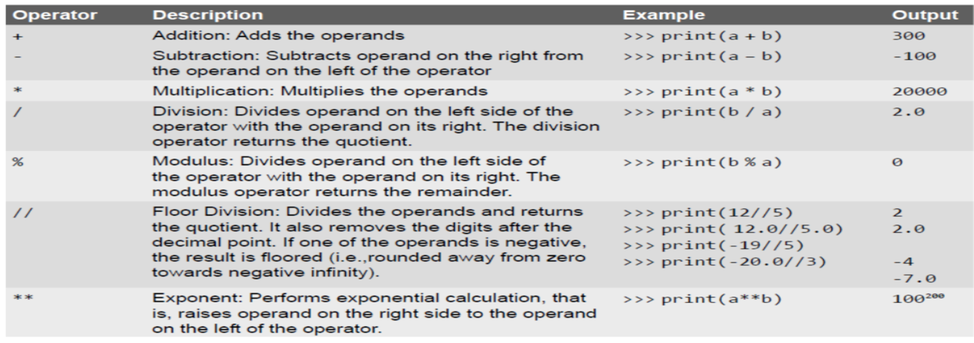

**6>LOGICAL OPERATOR:-**

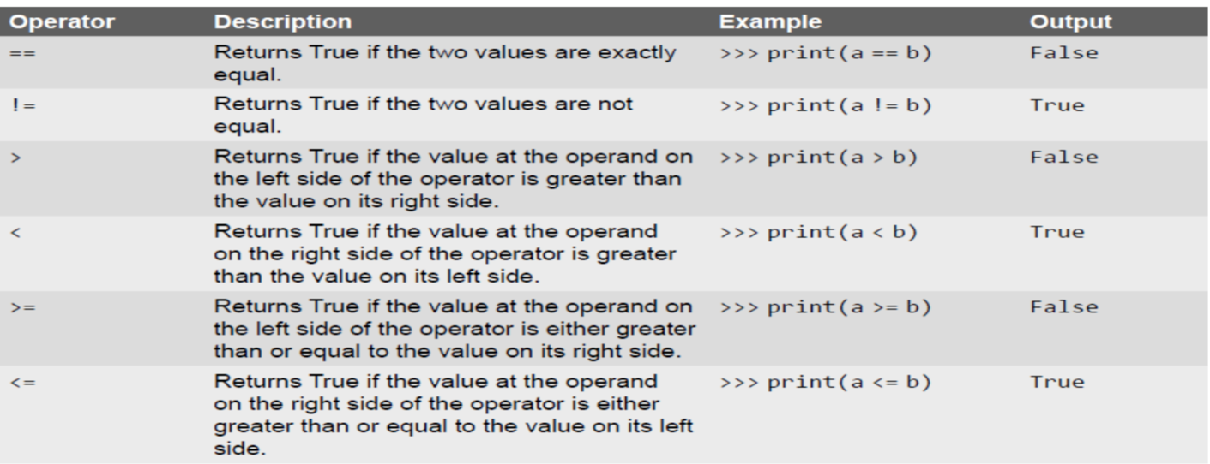

**7>KEYWORDS:-**

The following list shows the Python keywords. These are reserved words and you cannot use them as constant or variable or any other identifier names. All the Python keywords contain lowercase letters only.

**And, exec, not, assert, finally, or** , **break, for, pass, class, from, print, continue, global, raise def, if, return del, import, try elif, in, while else, is, with, except, lambda, yield.**

**VARIABLE TYPES**

Data types are the classification or categorization of data items. It represents the kind of value that tells what operations can be performed on a particular data. Since everything is an object in Python programming, data types are classes and variables are instances (objects) of these classes. The following are the standard or built-in data types in Python:

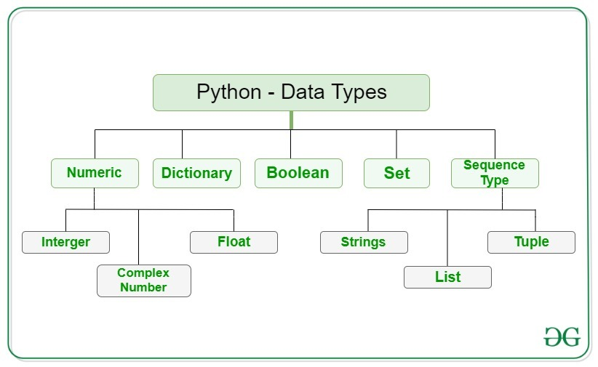

## **Numeric Data Types in Python**

The numeric data type in Python represents the data that has a numeric value. A numeric value can be an integer, a floating number, or even a complex number.

* **Integers**– This value is represented by int class. It contains positive or negative whole numbers (without fractions or decimals). In Python, there is no limit to how long an integer value can be.
* **Float**– This value is represented by the float class. It is a real number with a floating-point representation. It is specified by a decimal point. Optionally, the character e or E followed by a positive or negative integer may be appended to specify scientific notation.
* **Complex Numbers** – A complex number is represented by a complex class. It is specified as *(real part) + (imaginary part)j*. For example – 2+3j

## **Sequence Data Type in Python**

The sequence Data Type in Python is the ordered collection of similar or different data types. Sequences allow storing of multiple values in an organized and efficient fashion.

**String Data Type**

String in Python are arrays of bytes representing Unicode characters. A string is a collection of one or more characters put in a single quote, double-quote, or triple-quote. In Python there is no character data type, a character is a string of length one. It is represented by str class.

**List Data Type**

Lists are just like arrays, declared in other languages which is an ordered collection of data. It is very flexible as the items in a list do not need to be of the same type

**Tuple Data Type**

Just like a list, a [tuple](https://www.geeksforgeeks.org/python-tuples/) is also an ordered collection of Python objects. The only difference between a tuple and a list is that tuples are immutable i.e. tuples cannot be modified after it is created. It is represented by a tuple class.

**Boolean Data Type in Python**

Data type with one of the two built-in values, True or False. Boolean objects that are equal to True are truthy (true), and those equal to False are falsy (false). However non-Boolean objects can be evaluated in a Boolean context as well and determined to be true or false. It is denoted by the class bool.

**Set Data Type in Python**

In Python, a [Set](https://www.geeksforgeeks.org/python-sets/) is an unordered collection of data types that is iterable, mutable, and has no duplicate elements. The order of elements in a set is undefined though it may consist of various elements.

**Dictionary Data Type in Python**

A dictionary in Python is an unordered collection of data values, used to store data values like a map, unlike other Data Types that hold only a single value as an element, a Dictionary holds a key: value pair. Key-value is provided in the dictionary to make it more optimized. Each key-value pair in a Dictionary is separated by a colon : , whereas each key is separated by a ‘comma’.

**FUNCTIONS**

Python enables its programmers to break up a program into segments commonly known as functions, each of which can be written more or less independently of the others. Every function in the program is supposed to perform a well-defined task.

**Function Declaration and Definition**

• A function, f that uses another function g, is known as the calling function and g is known as the called function.

•The inputs that the function takes are known as arguments/parameters.

•When a called function returns some result back to the calling function, it is said to return that result.

• The calling function may or may not pass parameters to the called function. If the called function accepts

arguments, the calling function will pass parameters, else not.

• Function declaration is a declaration statement that identifies a function with its name, a list of arguments

that it accepts and the type of data it returns.

• Function definition consists of a function header that identifies the function, followed by the body of the

function containing the executable code for that function.

**Function Definition**

Function blocks starts with the keyword def.

•The keyword is followed by the function name and parentheses (( )).

• After the parentheses a colon (:) is placed.

• Parameters or arguments that the function accept are placed within parentheses.

•The first statement of a function can be an optional statement - the docstring describe what the function does.

•The code block within the function is properly indented to form the block code.

• A function may have a return[expression] statement.That is, the return statement is optional.

**EXAMPLE:-**

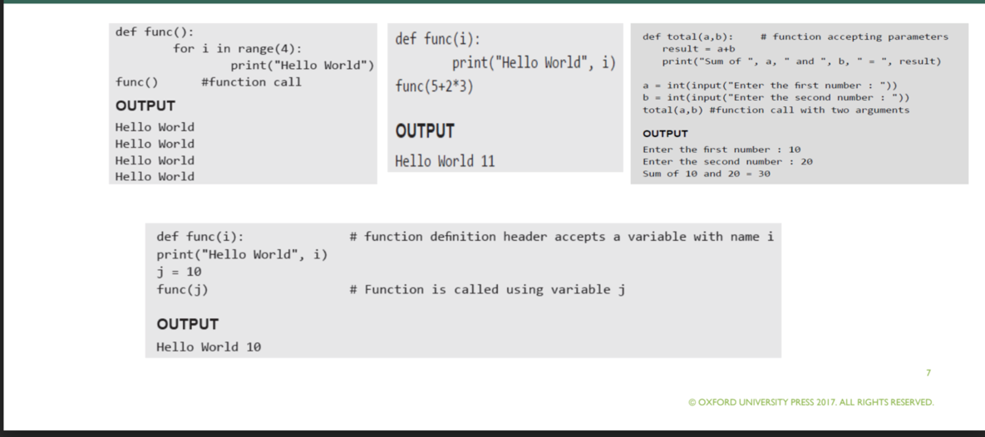

Pass by reference vs Pass by value

All parameters (arguments) in the Python language are passed by reference. It means if you change what a parameter refers to within a function, the change also reflects back in the calling function. For example –

*# Function definition is here*

defchange me(mylist):

"This changes a passed list into this function"

mylist.append([1,2,3,4]);

print"Values inside the function: ",mylist

return

*# Now you can call changeme function*

mylist=[10,20,30];

change me(mylist);

print” Values outside the function: ",mylist

Here, we are maintaining reference of the passed object and appending values in the same object. So, this would produce the following result −

Values inside the function: [10, 20, 30, [1, 2, 3, 4]]

Values outside the function: [10, 20, 30, [1, 2, 3, 4]]

**INTRODUCTION TO MACHINE LEARNING**

Machine learning is programming computers to optimize a performance criterion using example data or past experience. We have a model defined up to some parameters, and learning is the execution of a computer program to optimize the parameters of the model using the training data or past experience. The model may be predictive to make predictions in the future, or descriptive to gain knowledge from data.

The field of study known as machine learning is concerned with the question of how to construct computer programs that automatically improve with experience.

# **Supervised Machine Learning**

Supervised learning is the types of machine learning in which machines are trained using well "labelled" training data, and on basis of that data, machines predict the output. The labelled data means some input data is already tagged with the correct output.

In supervised learning, the training data provided to the machines work as the supervisor that teaches the machines to predict the output correctly. It applies the same concept as a student learns in the supervision of the teacher.

Supervised learning is a process of providing input data as well as correct output data to the machine learning model. The aim of a supervised learning algorithm is to **find a mapping function to map the input variable(x) with the output variable(y)**.

In the real-world, supervised learning can be used for **Risk Assessment, Image classification, Fraud Detection, spam filtering**, etc.

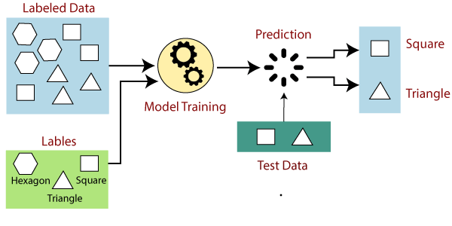

# **Unsupervised Machine Learning**

As the name suggests, unsupervised learning is a machine learning technique in which models are not supervised using training dataset. Instead, models itself find the hidden patterns and insights from the given data. It can be compared to learning which takes place in the human brain while learning new things. It can be defined as:

Unsupervised learning cannot be directly applied to a regression or classification problem because unlike supervised learning, we have the input data but no corresponding output data. The goal of unsupervised learning is to **find the underlying structure of dataset, group that data according to similarities, and represent that dataset in a compressed format**.

**Example:** Suppose the unsupervised learning algorithm is given an input dataset containing images of different types of cats and dogs. The algorithm is never trained upon the given dataset, which means it does not have any idea about the features of the dataset. The task of the unsupervised learning algorithm is to identify the image features on their own. Unsupervised learning algorithm will perform this task by clustering the image dataset into the groups according to similarities between images.

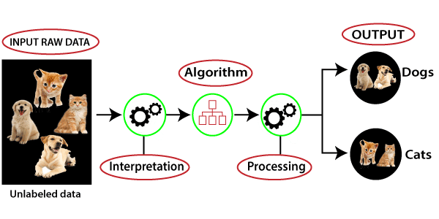

NUMPY

• NumPy is the short form of “Numeric Python”

• It is a package that contains several classes, functions, variables etc. to deal with scientific calculations in Python

• NumPy is useful to create and also process single and multidimensional arrays

• NumPy array is a central data structure of the NUMPY LIB. .

• One of the tools in NumPy is high array object that is a powerful data structure for efficient computation

of arrays and matrices

• NumPy also contains a large library of mathematical functions viz.

Linear algebra functions , Fourier Transforms

• NumPy contains both an array class and a matrix class

**Indexing refers to the locations of the elements**

• Example: arr = np.array([1, 7, 5, -4, 8,-3])

• arr[0] = 1 arr[3] = -4

**• Slicing refers to extraction of a range of elements from the array**

• Format for slicing arrayname[start : stop : stepsize]

• arr[1:5] => [7, 5, -4, 8]

• arr[1:6:2] => [7, -4, -3]

• arr[::] => [1, 7, 5, -4, 8, -3]

• arr[:] => [1, 7, 5, -4, 8, -3]

• arr[3:] => [-4, 8, -3]

• arr[-1:-4:-1] => [-3, 8, -4]

• # length = 6; start = -1 + 6 = 5; stop = -4 + 6 = 2;

SCIKIT-LEARN

## **What is Scikit-Learn (Sklearn):-**

Scikit-learn (Sklearn) is the most useful and robust library for machine learning in Python. It provides a selection of efficient tools for machine learning and statistical modeling including classification, regression, clustering and dimensionality reduction via a consistence interface in Python. This library, which is largely written in Python, is built upon **NumPy, SciPy** and **Matplotlib**.

## **Origin of Scikit-Learn:-**

It was originally called ***scikits.learn*** and was initially developed by David Cournapeau as a Google summer of code project in 2007. Later, in 2010, Fabian Pedregosa, Gael Varoquaux, Alexandre Gramfort, and Vincent Michel, from FIRCA (French Institute for Research in Computer Science and Automation), took this project at another level and made the first public release (v0.1 beta) on 1st Feb. 2010.

## **Features:-**

Rather than focusing on loading, manipulating and summarising data, Scikit-learn library is focused on modeling the data. Some of the most popular groups of models provided by Sklearn are as follows −

**Supervised Learning algorithms** − Almost all the popular supervised learning algorithms, like Linear Regression, Support Vector Machine (SVM), Decision Tree etc., are the part of scikit-learn.

**Unsupervised Learning algorithms** − On the other hand, it also has all the popular unsupervised learning algorithms from clustering, factor analysis, PCA (Principal Component Analysis) to unsupervised neural networks.

**Clustering** − This model is used for grouping unlabeled data.

**Cross Validation** − It is used to check the accuracy of supervised models on unseen data.

**Dimensionality Reduction** − It is used for reducing the number of attributes in data which can be further used for summarisation, visualisation and feature selection.

**Ensemble methods** − As name suggest, it is used for combining the predictions of multiple supervised models.

**Feature extraction** − It is used to extract the features from data to define the attributes in image and text data.

**Feature selection** − It is used to identify useful attributes to create supervised models.

**Open Source** − It is open source library and also commercially usable under BSD license.

MATPLOTLIB

[Matplotlib](https://www.geeksforgeeks.org/python-matplotlib-an-overview/) is an amazing visualization library in [Python](https://www.geeksforgeeks.org/python-programming-language/) for 2D plots of arrays. Matplotlib is a multi-platform data visualization library built on [NumPy](https://www.geeksforgeeks.org/python-numpy/) arrays and designed to work with the broader SciPy stack. It was introduced by John Hunter in the year 2002. One of the greatest benefits of visualization is that it allows us visual access to huge amounts of data in easily digestible visuals. Matplotlib consists of several plots like line, bar, scatter, histogram, etc.

By importing the matplotlib module, defines x and y values for a plot**Python**, plots the data using the plot() function and it helps to display the plot by using the show() function . The plot() creates a line plot by connecting the points defined by x and y values.

Python3

|  |
| --- |
| from matplotlib import pyplot as plt  x = [5, 2, 9, 4, 7]  y = [10, 5, 8, 4, 2]  plt.plot(x, y)  plt.show() |

**Output:**

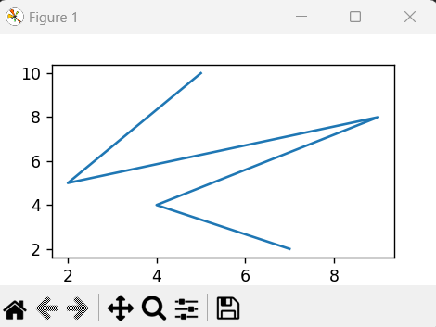

*Line Plot*

**Matplotlib Bar Plot**

By using[matplotlib](https://www.geeksforgeeks.org/python-matplotlib-an-overview/) library in Python**two**, it allows us to access the functions and classes provided by the library for plotting. There are tow listsx and y are defined . This function creates a bar plot by taking x-axis and y-axis values as arguments and generates the bar plot based on those values.

Python3

|  |
| --- |
| # importing matplotlib module  from matplotlib import pyplot as plt  x = [5, 2, 9, 4, 7]  y = [10, 5, 8, 4, 2]  plt.bar(x, y)  plt.show() |

**Output**:

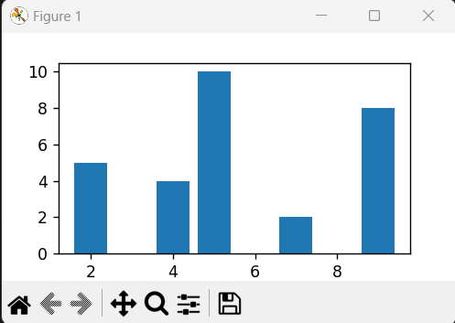

*Bar Plot*

**Matplotlib Histograms Plot**

By using the matplotlib module defines the y-axis values for a histogram plot. Plots in the **,**histogram using the hist() function and displays the plot using the show() function. The hist() function creates a histogram plot based on the values in the y-axis list.

Python3

|  |
| --- |
| from matplotlib import pyplot as plt  y = [10, 5, 8, 4, 2]  plt.hist(y)  plt.show() |

**Output:**

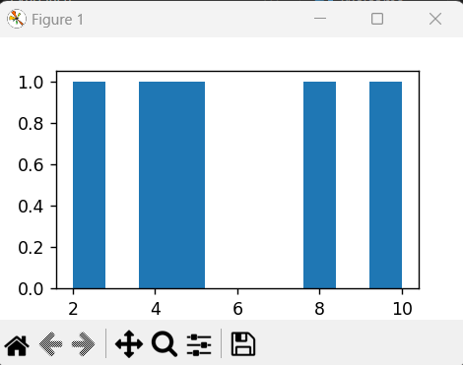

*Histogram*

**Matplotlib Scatter Plot**

By imports,**plot** the matplotlib module, defines x and y values for a scatter plot, plots the data using the scatter() function, and displays the plot using the show() function. The scatter() function creates a scatter plot by plotting individual data points defined by the x and y values.

Python3

|  |
| --- |
| # importing matplotlib module  from matplotlib import pyplot as plt  x = [5, 2, 9, 4, 7]  y = [10, 5, 8, 4, 2]  plt.scatter(x, y)  plt.show() |

**Output :**

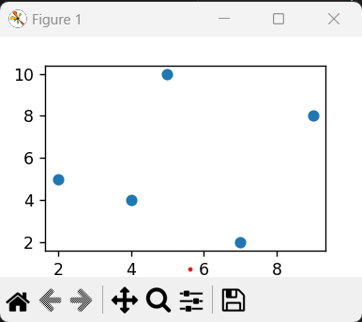

*Scatter Plot*

We can also plot a scatter plot using the [**plot()**](https://www.geeksforgeeks.org/matplotlib-pyplot-plot-function-in-python/) method by providing the marker style as ‘o’.

Python3

|  |
| --- |
| from matplotlib import pyplot as plt  x = [5, 2, 9, 4, 7]  y = [10, 5, 8, 4, 2]  plt.plot(x, y, 'o')  plt.show() |

**Output:**

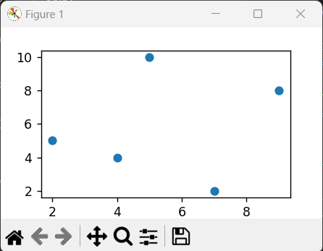

*Scatter Plot by using plot()*

**Matplotlib Pie Charts**

By importing the module Matplotlib in Python to create a pie chart with three categories and respective sizes. The[plot.pie()](https://www.geeksforgeeks.org/plot-a-pie-chart-in-python-using-matplotlib/) function is used to generate the chart, including labels, percentage formatting, and a starting angle. A title is added with [plt. title(),](https://www.geeksforgeeks.org/matplotlib-pyplot-title-in-python/) and [plt. show()](https://www.geeksforgeeks.org/matplotlib-pyplot-show-in-python/)displays the resulting pie chart, visualizing the proportional distribution of the specified categories.

|  |
| --- |
| import matplotlib.pyplot as plt  labels = ['Geeks 1', 'Geeks 2', 'Geeks 3']  sizes = [35, 35, 30]  plt.pie(sizes, labels=labels, autopct='%1.1f%%', startangle=90)  plt.title('Pie Chart Example')  plt.show() |

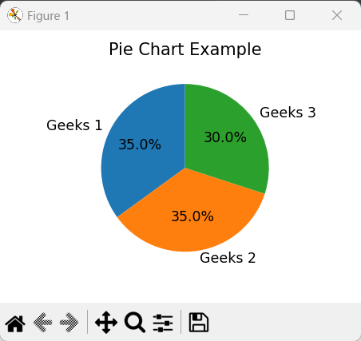

PANDAS

In computer programming, **pandas** is a software library written for the Python programming language for data manipulation and analysis. In particular, it offers data structures and operations for manipulating numerical tables and time series. It is free software released under the three-clause BSD license. "Panel data", an econometrics term for multidimensional, structured data sets.

**LIBRARY FEATURES**

* Data Frame object for data manipulation with integrated indexing.
* Tools for reading and writing data between in-memory data structures and different file formats.
* Data alignment and integrated handling of missing data.
* Reshaping and pivoting of data sets.
* Label-based slicing, fancy indexing, and sub setting of large data sets.
* Data structure column insertion and deletion.
* Group by engine allowing split-apply-combine operations on data sets.
* Data set merging and joining.
* Hierarchical axis indexing to work with high-dimensional data in a lower-dimensional data structure.
* Time series-functionality: Date range generation.

REGRESSION ANALYSIS

Regression analysis is a statistical method to model the relationship between a dependent (target) and independent (predictor) variables with one or more independent variables. More specifically, Regression analysis helps us to understand how the value of the dependent variable is changing corresponding to an independent variable when other independent variables are held fixed. It predicts continuous/real values such as **temperature, age, salary, price,** etc.

Linear Regression:

* Linear regression is a statistical regression method which is used for predictive analysis.
* It is one of the very simple and easy algorithms which works on regression and shows the relationship between the continuous variables.
* It is used for solving the regression problem in machine learning.
* Linear regression shows the linear relationship between the independent variable (X-axis) and the dependent variable (Y-axis), hence called linear regression.
* If there is only one input variable (x), then such linear regression is called **simple linear regression**. And if there is more than one input variable, then such linear regression is called **multiple linear regression**.
* The relationship between variables in the linear regression model can be explained using the below image. Here we are predicting the salary of an employee on the basis of **the year of experience**.

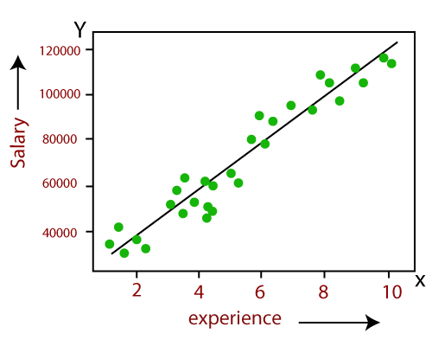

Logistic Regression:

* Logistic regression is another supervised learning algorithm which is used to solve the classification problems. In **classification problems**, we have dependent variables in a binary or discrete format such as 0 or 1.
* Logistic regression algorithm works with the categorical variable such as 0 or 1, Yes or No, True or False, Spam or not spam, etc.
* It is a predictive analysis algorithm which works on the concept of probability.
* Logistic regression is a type of regression, but it is different from the linear regression algorithm in the term how they are used.
* Logistic regression uses **sigmoid function** or logistic function which is a complex cost function. This sigmoid function is used to model the data in logistic regression. The function can be represented as:

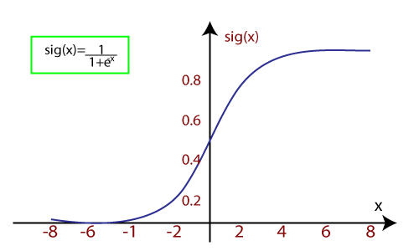

CLUSTERING

**Cluster analysis** or **clustering** is the task of grouping a set of objects in such a way that objects in the same group (called a **cluster**) are more similar (in some sense or another) to each other than to those in other groups (clusters). It is a main task of exploratory data mining, and a common technique for statistical data analysis, used in many fields, including machine learning, pattern recognition, image analysis, information retrieval, bioinformatics, data compression, and computer graphics.

Cluster analysis itself is not one specific algorithm, but the general task to be solved. It can be achieved by various algorithms that differ significantly in their notion of what constitutes a cluster and how to efficiently find them. Popular notions of clusters include groups with small distances among the cluster members, dense areas of the data space, intervals or particular statistical distributions. Clustering can therefore be formulated as a multi-objective optimization problem.

The appropriate clustering algorithm and parameter settings (including values such as the distance function to use, a density threshold or the number of expected clusters) depend on the individual data set and intended use of the results. Cluster analysis as such is not an automatic task, but an iterative process of knowledge discovery or interactive multi-objective optimization that involves trial and failure. It is often necessary to modify data pre-processing and model parameters until the result achieves the desired properties.

**IPL MATCHES ANALYSIS**

**ABSTRACT**

This project is about analyzing the Indian Premier League (IPL), which is a popular cricket league. The analysis will focus on player performance, team dynamics, and using machine learning to predict match scores.

To do this, we will collect and process IPL data, and then analyze it to identify trends and patterns over different seasons. We will look at individual player performance, team performance, and use machine learning to predict the final score of matches.

The goal of this project is to provide cricket enthusiasts, team management, and analysts with a comprehensive understanding of player and team dynamics, as well as offer insights into the multifaceted world of the IPL using statistical analysis and predictive modeling.

**INTRODUCTION**

The Indian Premier League (IPL) stands as one of the most captivating and widely followed cricket leagues globally, attracting top-tier talent from around the world. This data science project endeavors to provide a comprehensive analysis of various facets of the IPL, focusing on player performance, team dynamics, and the application of machine learning to predict match scores.

The project will commence with the collection and preprocessing of IPL datasets, incorporating detailed information on matches, players, and teams. The exploratory data analysis (EDA) will encompass a year-wise examination of matches played, runs, wickets, and other key metrics to uncover trends and patterns over different seasons.

The analysis will delve into identifying top runs getters and wicket getters, along with an in-depth fielding analysis encompassing catches, run-outs, and stumpings. Furthermore, player-centric metrics such as strike rate and average will be calculated to highlight individuals with exceptional batting performances.

In parallel, team performance will be scrutinized, differentiating their efficacy while batting first or bowling first. Win-loss ratios and team-level metrics will be analyzed to unveil overarching trends in team dynamics over the years.

The project will incorporate machine learning techniques to predict the final score of IPL matches. A predictive model will be trained on historical data, considering various factors such as batting and bowling team, current runs, wickets, overs, and recent performance trends. The accuracy and reliability of the model will be assessed through rigorous testing against actual match outcomes.

The amalgamation of exploratory data analysis and machine learning predictions aims to unravel hidden insights within the IPL dataset, providing cricket enthusiasts, team management, and analysts with a comprehensive understanding of player and team dynamics. The project aspires to contribute valuable insights into the multifaceted world of the IPL, offering a blend of statistical analysis and predictive modeling for a holistic perspective on this captivating cricketing phenomenon.

**LITERATURE REVIEW**

The Indian Premier League (IPL) has evolved into a global sporting phenomenon, capturing the attention of cricket enthusiasts and researchers alike. This literature review aims to provide an overview of existing studies that delve into the multifaceted world of the IPL, with a specific focus on data science analyses and the utilization of machine learning for predicting match scores.

1. **Player Performance Analysis:** Numerous studies have delved into individual player performances in the IPL, aiming to identify the top runs and wicket-getters. Researchers have employed statistical metrics such as strike rates and averages to assess the efficacy of players, thereby uncovering the key contributors to team success. This body of work sheds light on the pivotal roles played by standout players in influencing match outcomes.
2. **Fielding Dynamics:** While batting and bowling performances often take the spotlight, the role of fielding in the IPL has gained recognition in recent literature. Studies have explored fielding dynamics, scrutinizing catches, run-outs, and stumpings. These analyses emphasize the impact of agile and precise fielding on altering the course of a match, showcasing the significance of a well-rounded team.
3. **Team Performance Metrics:** Understanding team dynamics is crucial for comprehending IPL outcomes. Research in this domain has focused on analyzing team performances, particularly when batting first or bowling first. Win-loss ratios, team-level metrics, and strategic considerations have been investigated to discern patterns and trends across different IPL seasons.
4. **Machine Learning Applications:** The integration of machine learning techniques into IPL analyses has become increasingly prevalent. Researchers have developed predictive models aimed at forecasting match scores. These models consider a multitude of variables, including team dynamics, current scores, wickets, overs, and recent performance trends. While showcasing promise, these studies also address challenges such as overfitting and data variability.
5. **Predictive Modeling Challenges:** Despite the advancements in predictive modeling, challenges persist. The literature highlights issues like overfitting and the variability of cricket match data. Researchers have proposed refined methodologies, including feature engineering and model regularization, to enhance the accuracy and reliability of score prediction models.

METHODOLOGY & ALGORITHMS

**DATA SET:-**

1. <https://www.kaggle.com/datasets/vora1011/ipl-2008-to-2021-all-match-dataset/data#:~:text=calendar_view_week-,IPL_Ball_by_Ball_2008_2022,-.csv>
2. <https://www.kaggle.com/datasets/vora1011/ipl-2008-to-2021-all-match-dataset/data#:~:text=calendar_view_week-,IPL_Matches_2008_2022,-.csv>
3. <https://github.com/zep-analytics/IPLScorePredictor/blob/main/IPL_Score_Predictor.ipynb#:~:text=ipl_data.-,csv,-ipl_score_predictor.py>

**1 & 2 are used for Match analysis & 3 is used for ipl match score prediction using ML**

**LIBRARY USED:-**

**Pandas**: Used for data manipulation, cleaning, and exploration. It provides versatile data structures (e.g., DataFrames) and functions.

**Matplotlib**: Employed for data visualization, offering a wide range of plotting options to create insightful graphs and charts.

i.**Bar Graph**:- Utilized for representing categorical data and making comparisons between different groups or categories, such as team-wise performance metrics.

ii.**Pie Chart**:-Employed for illustrating the proportion of each category in a dataset, often used for visualizing distribution, such as the distribution of wickets taken by different players or teams.

**Scikit-learn Library**: Utilized for creating visualizations related to machine learning, such as confusion matrices or learning curves, to assess model performance.

**Data Preprocessing Techniques:**

**Label Encoding**: Transforming categorical variables into numerical labels to make them compatible with machine learning algorithms.

**One-Hot Encoding**: Expanding categorical variables into binary columns for each category, often used when categorical variables are not ordinal.

**Machine Learning Algorithms:**

**Linear Regression**:

**Purpose:** Predicting numerical values (final score of an IPL match).

**Strengths**: Simplicity, ease of interpretation, and fast training.

**Considerations**: Assumes a linear relationship between features and the target variable.

**K-Nearest Neighbors (KNN):**

**Purpose**: Used for both classification and regression tasks based on the 'k' nearest neighbors.

**Strengths**: Intuitive, non-parametric, and adaptable to different data distributions.

**Considerations**: Sensitive to outliers, and the choice of 'k' can impact performance.

**Decision Tree:**

**Purpose**: Employed for classification and regression by recursively splitting the data based on feature thresholds.

**Strengths**: Easy to understand, interpretable, and handles non-linear relationships.

**Considerations**: Prone to overfitting, especially with deep trees.

**Random Forest:**

**Purpose:** Ensemble method that builds multiple decision trees and merges their predictions.

**Strengths:** Reduces overfitting, handles high-dimensional data, and provides feature importance.

**Considerations:** May require tuning, and interpretation can be more complex than a single decision tree.

**Support Vector Machine (SVM) with Radial Basis Function (RBF) Kernel:**

Purpose: Used for classification and regression tasks, creating a hyperplane in a high-dimensional space.

Strengths: Effective in high-dimensional spaces, and versatile for different kernel functions.

Considerations: May be sensitive to parameter tuning, and computational complexity can be high.

**Naive Bayes:**

**Purpose**: Particularly useful for classification tasks, assumes independence between features given the class.

**Strengths**: Simple, computationally efficient, and effective for certain types of data distributions.

**Considerations**: Assumes independence, which may not hold in all cases.

USED R^2 SCORE TO CHECK THE ALGORITHMS :-

R-squared is a statistical measure that represents the goodness of fit of a regression model. The value of R-square lies between 0 to 1. Where we get R-square equals 1 when the model perfectly fits the data and there is no difference between the predicted value and actual value.

PARAMETERS OF ERROR:- MEAN ABSOLUTE ERROR

MEAN SQUARED ERROR

ROOT MEAN SQUARED ERROR

Advantages & Disadvantages with limitation

#### **Advantages :-**

**Performance Evaluation:** The project provides a robust framework for evaluating individual player and team performances, aiding cricket analysts, coaches, and team management in assessing strengths and weaknesses.

**Strategic Insights:** Insights derived from machine learning models and visualizations can offer strategic guidance for teams. Understanding trends in player performance, optimal strategies when batting or bowling first, and other metrics can inform game plans.

**Talent Identification**: By analyzing top runs getters, wicket getters, and players with high strike rates and averages, the project contributes to talent identification. This information is valuable for scouting new talents and nurturing emerging players.

**Fielding Improvement**: The fielding analysis can be particularly beneficial for teams looking to enhance their fielding capabilities. Identifying players or teams with exceptional fielding records can serve as a benchmark for improvement.

**Predictive Analytics**: The machine learning models for score prediction offer a forward-looking perspective. Teams can use these predictions for match preparation, tactical decisions, and understanding the potential outcome based on current match conditions.

#### **Disadvantages and Limitations:-**

**Data Limitations:** The accuracy of predictions and analyses relies heavily on the quality and completeness of historical IPL data. Incomplete or inaccurate data may lead to biased insights and predictions.

**Overreliance on Historical Data:** Predictive models are built on historical data, and they assume that past patterns will continue. Sudden changes in player form, strategies, or external factors might impact the model's accuracy.

**Interpretability Challenges:** Complex machine learning models, such as Random Forest or Support Vector Machine, may lack interpretability. Cricket stakeholders might find it challenging to understand the reasoning behind specific predictions.

**Dynamic Nature of Cricket:** Cricket is inherently dynamic, with match conditions, player form, and strategies evolving. Predictive models may struggle to capture the constantly changing dynamics of the game.

**Limited Context Consideration:** Machine learning models might not consider specific contextual factors, such as player injuries, team dynamics, or external influences, which can significantly impact match outcomes.

**Overfitting Risk:** Depending on the complexity of the machine learning models, there is a risk of overfitting to historical data. Overfit models may not generalize well to new scenarios or seasons.

**\*\*Some important term required**

**Batsman Strike Rate:**

**Definition**: The batsman's strike rate is a measure of how quickly a batsman scores runs. It is calculated as the number of runs scored per 100 balls faced.

**Formula**: Strike Rate = (Runs Scored / Balls Faced) * 100

**Interpretation:** A high strike rate indicates an aggressive and quick-scoring batsman, while a lower strike rate may suggest a more defensive or patient approach.

**Importance:** Strike rate is crucial in limited-overs formats like One Day Internationals (ODIs) and Twenty20 (T20) matches, where scoring quickly is often essential.

**Batsman Average:**

**Definition:** Batting average is the average number of runs a batsman scores per dismissal (out).

**Formula:** Batting Average = (Total Runs Scored / Number of Times Out)

**Interpretation:** A high batting average signifies consistent run-scoring, reflecting a batsman's ability to contribute significantly each time they go to bat.

**Importance:** Batting average is a key metric in assessing a batsman's overall performance, providing insights into their consistency and ability to convert starts into substantial innings.

**Bowler Strike Rate:**

**Definition**: Bowler strike rate is a measure of how quickly a bowler takes wickets. It is calculated as the average number of balls bowled per wicket taken.

**Formula:** Bowler Strike Rate = (Balls Bowled / Wickets Taken)

**Interpretation:** A lower strike rate suggests a bowler is more effective in taking wickets quickly, while a higher strike rate may indicate a bowler takes more balls to make breakthroughs.

**Importance:** A low strike rate is generally preferred for bowlers as it signifies their ability to make an impact and provide breakthroughs for the team.

**Bowler Average:**

**Definition:** Bowling average is the average number of runs a bowler concedes per wicket taken.

**Formula:** Bowling Average = (Total Runs Conceded / Number of Wickets Taken)

**Interpretation:** A lower bowling average indicates that the bowler is effective in restricting opposition batsmen, taking wickets at a relatively lower cost.

**Importance:** Bowling average is a key metric in evaluating a bowler's effectiveness in terms of both wicket-taking ability and economical bowling.

Actual Codes

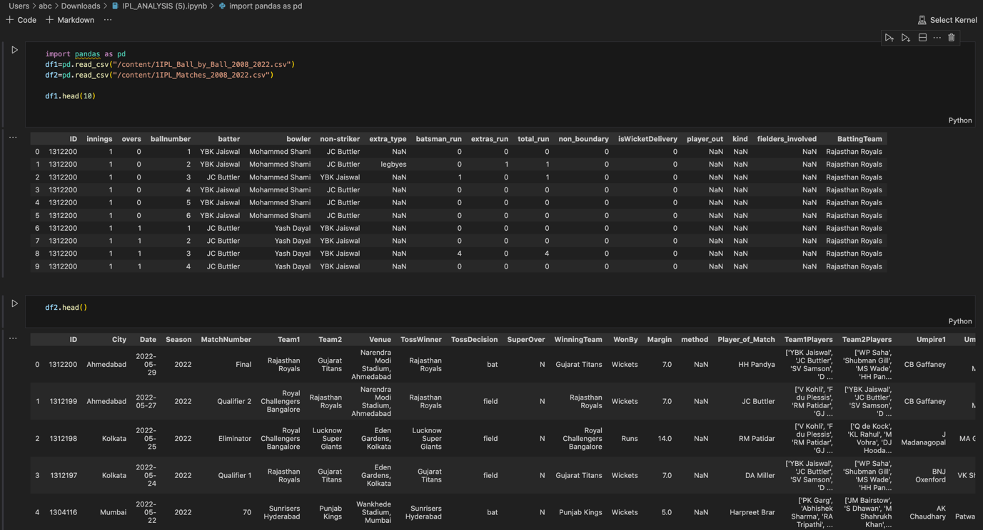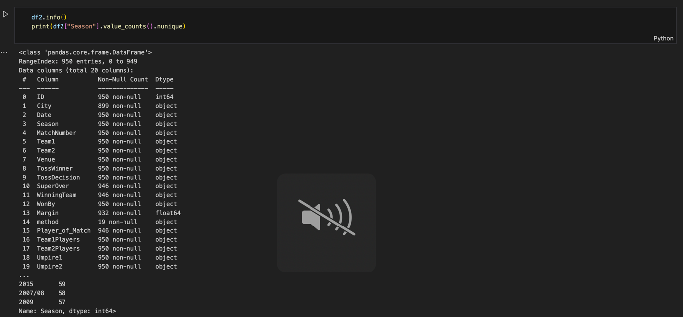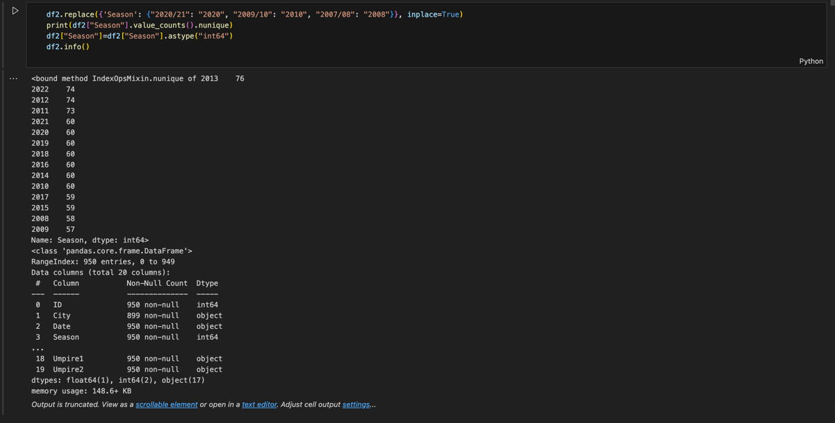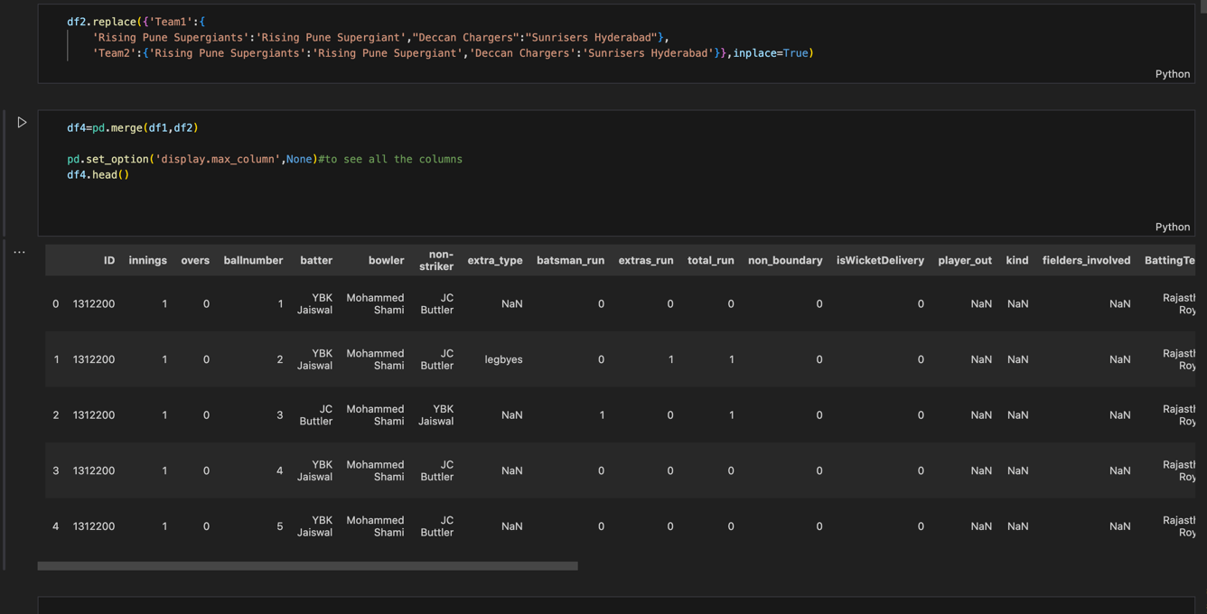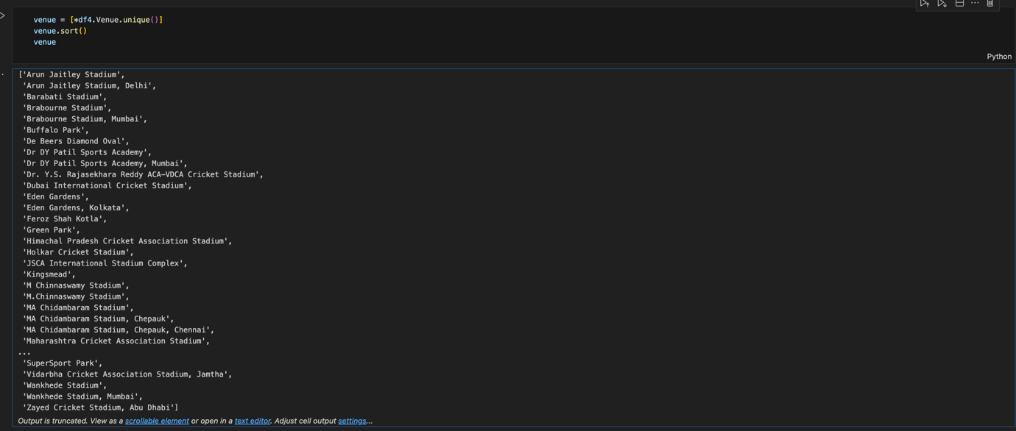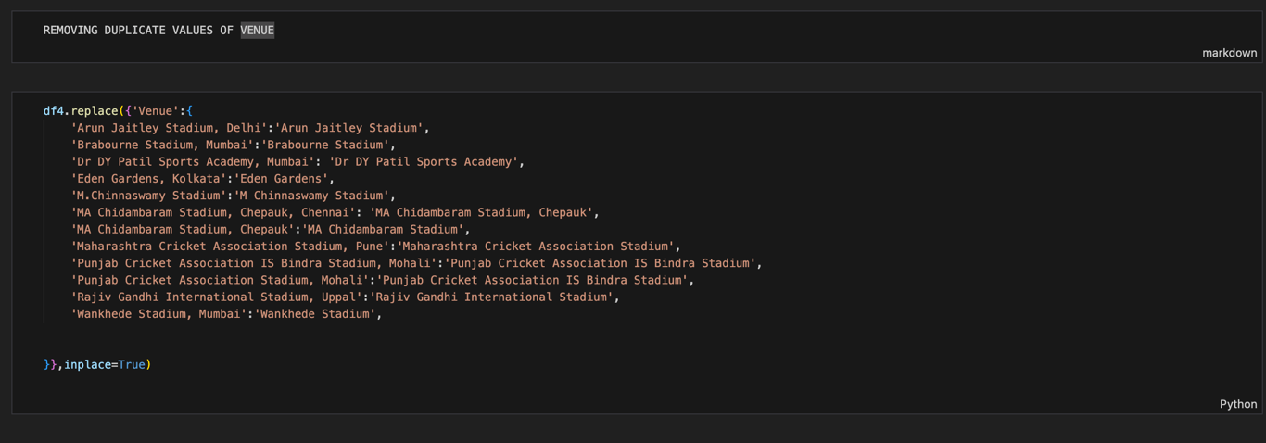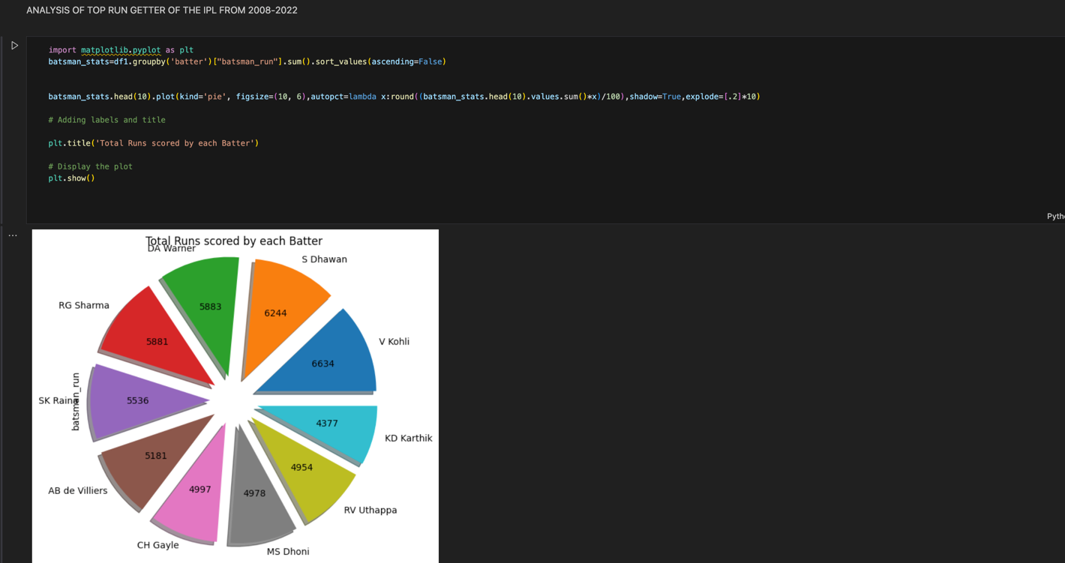

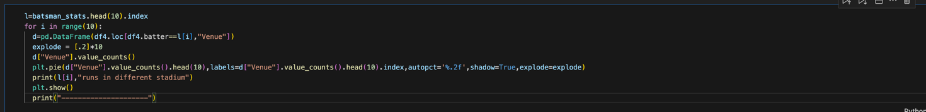

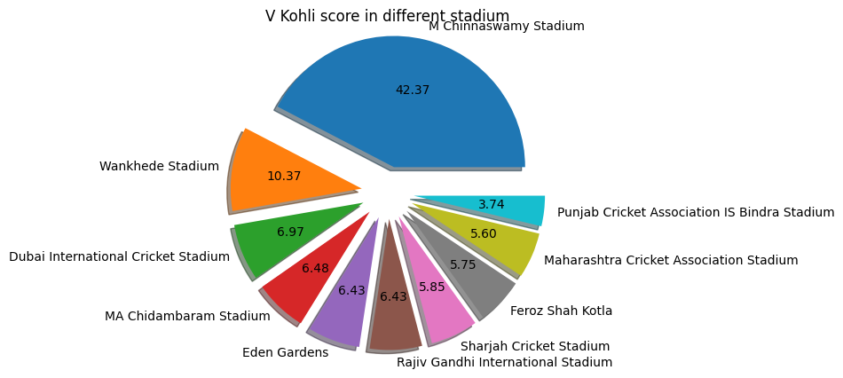 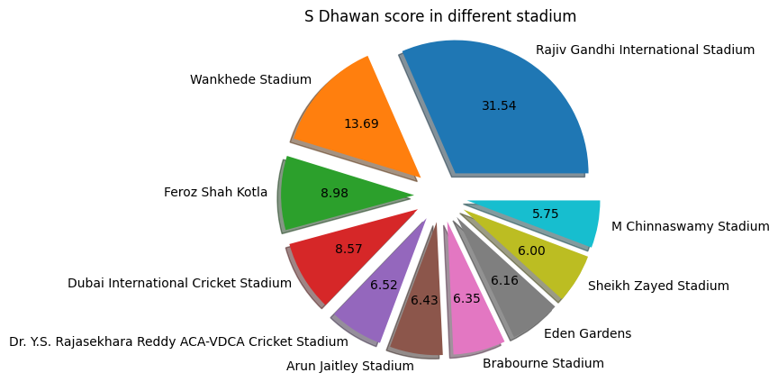

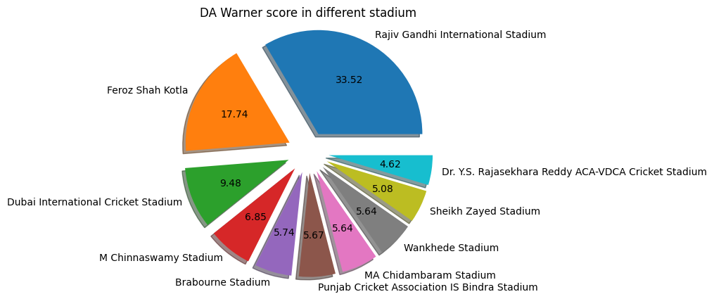 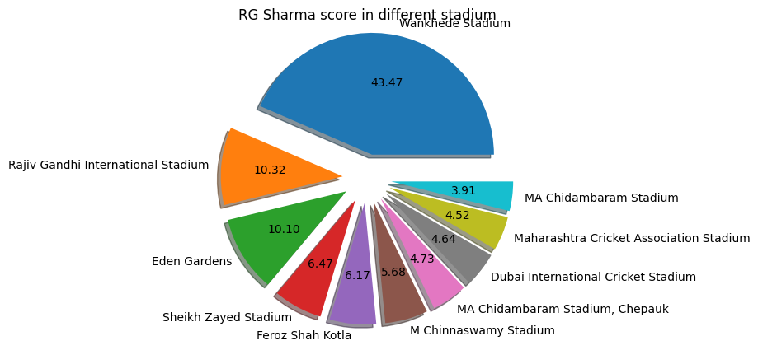

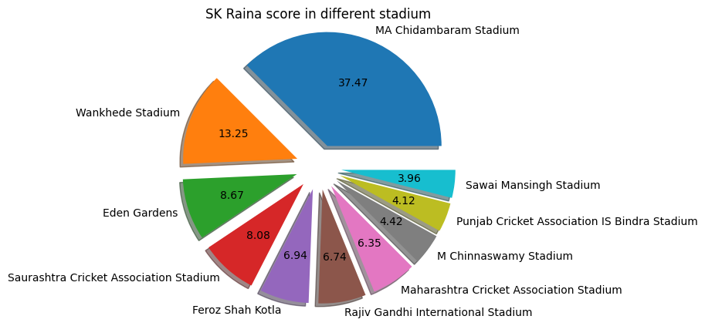 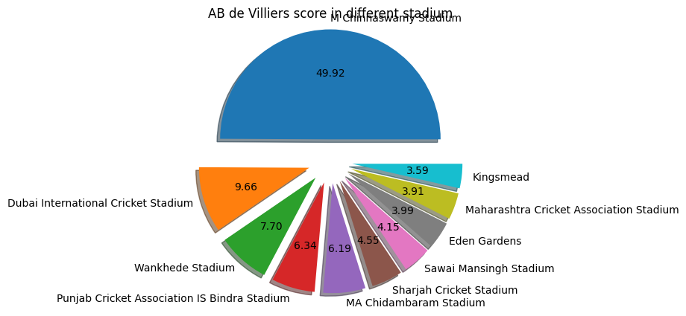

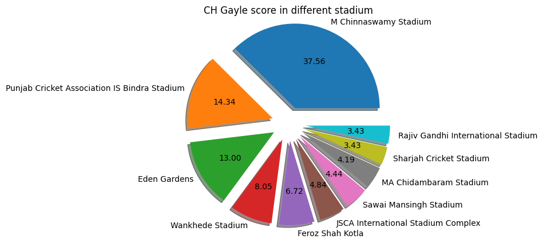 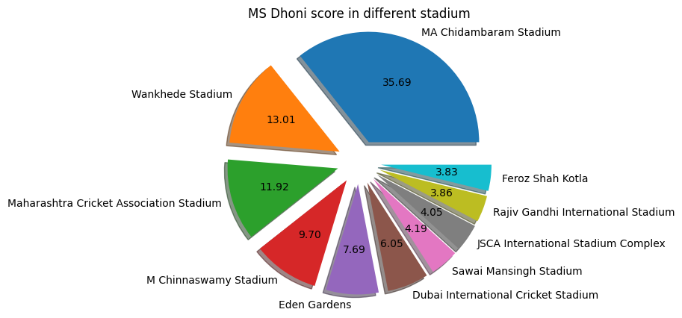

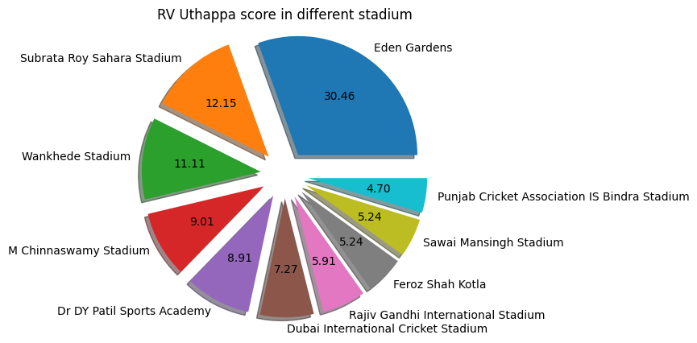 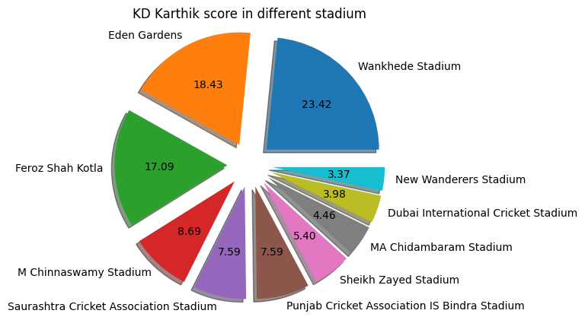

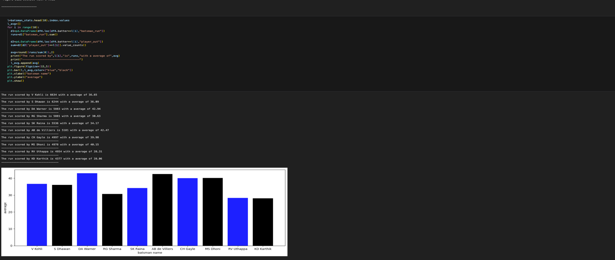

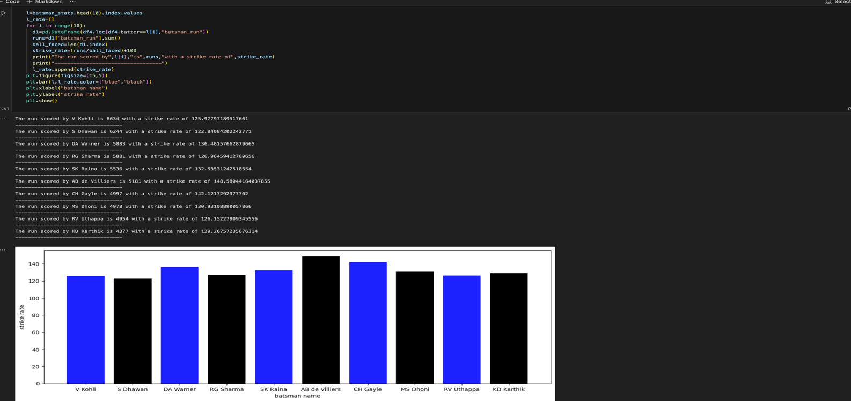

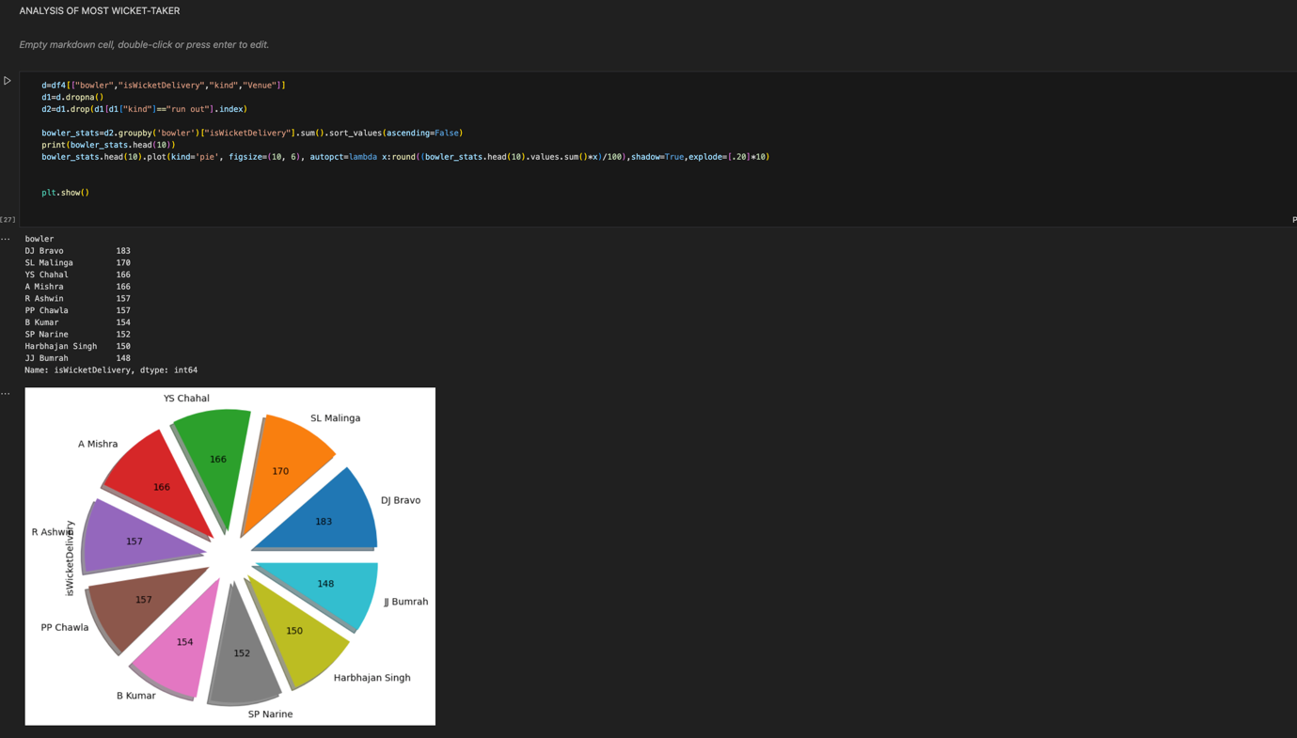

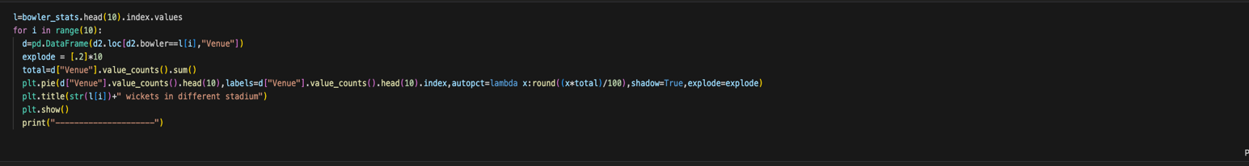

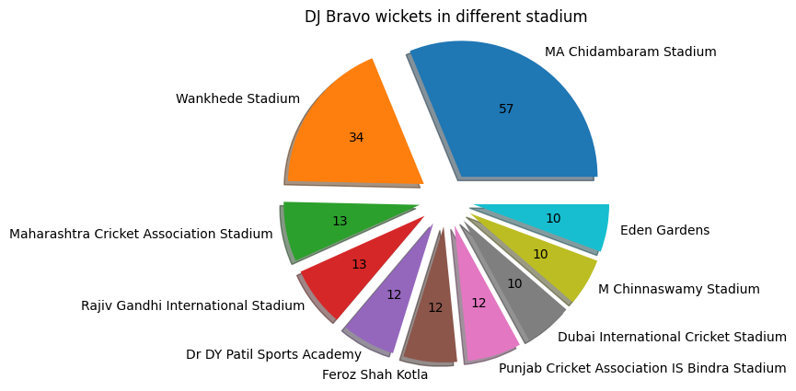 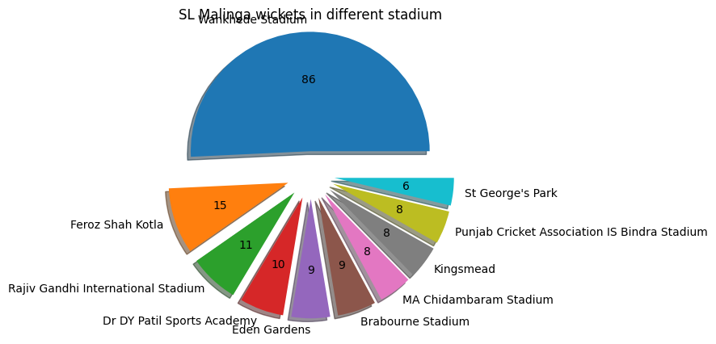

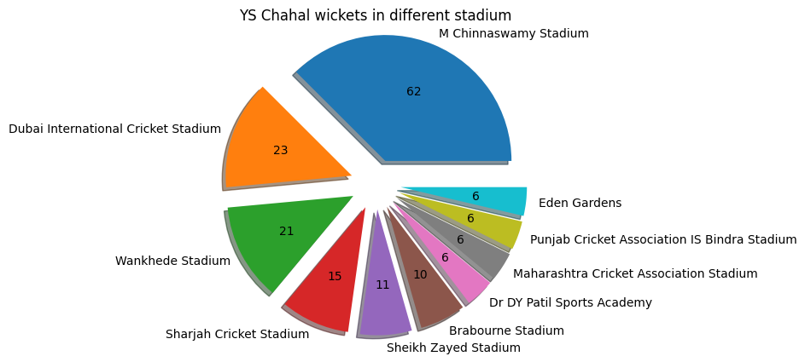 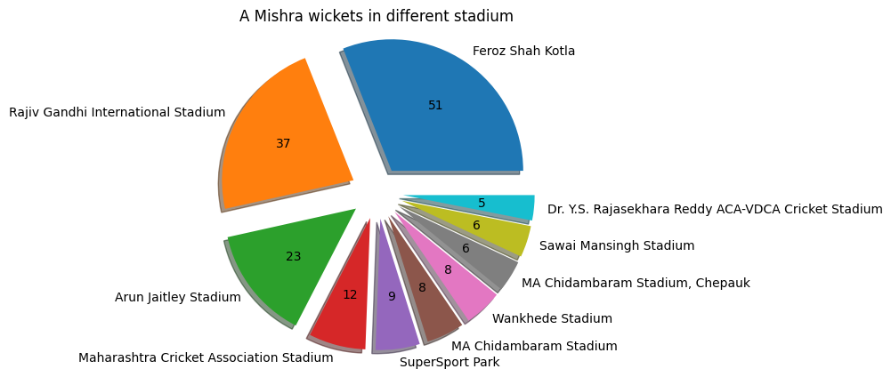

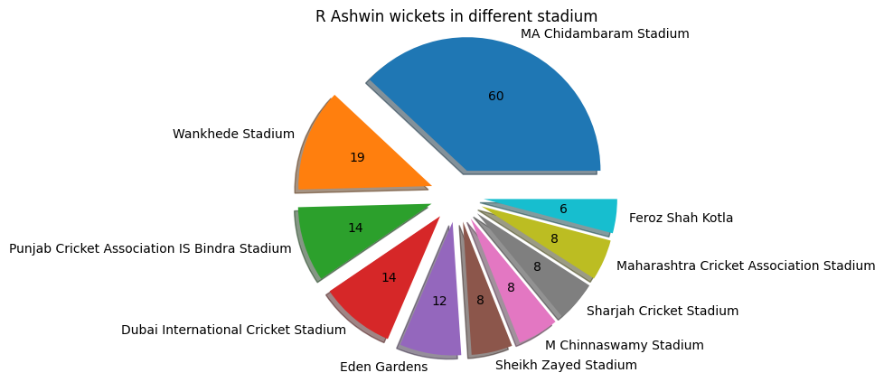 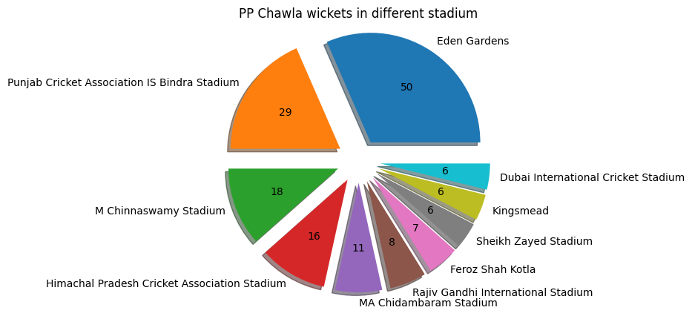

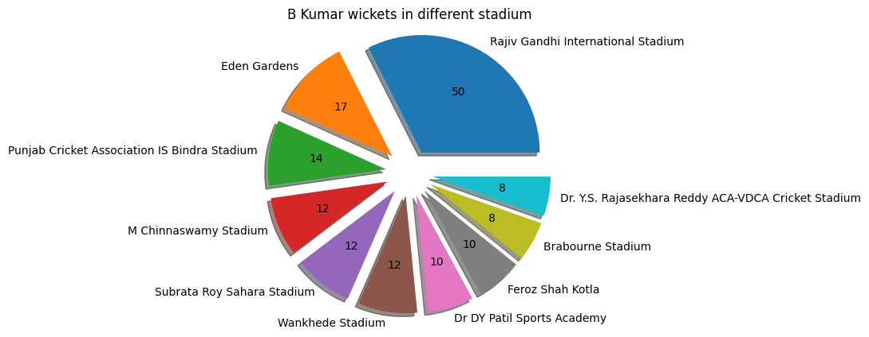 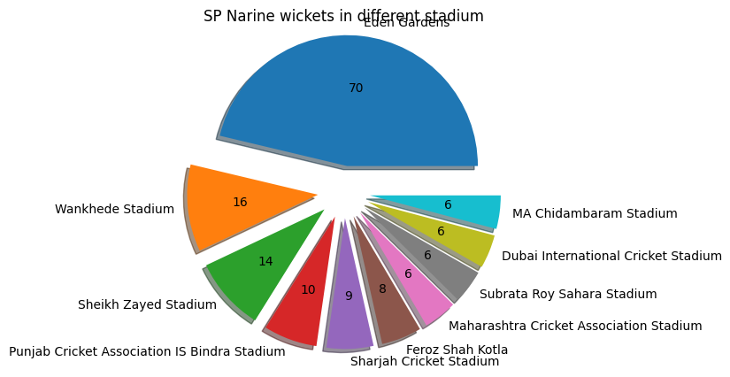

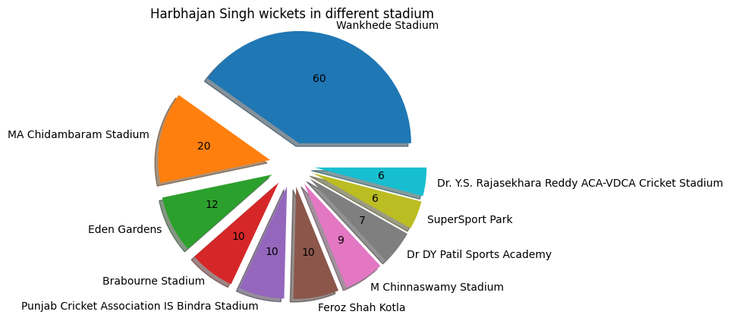 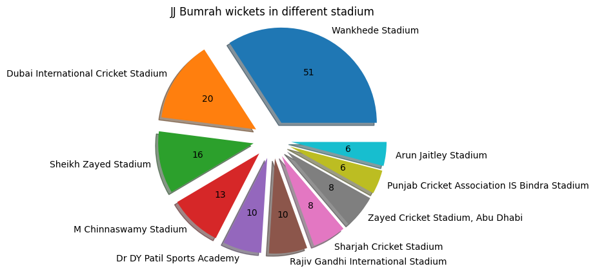

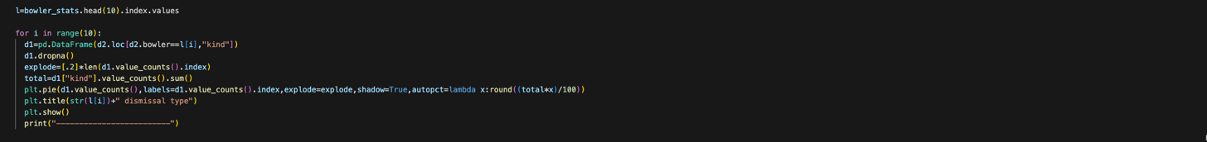

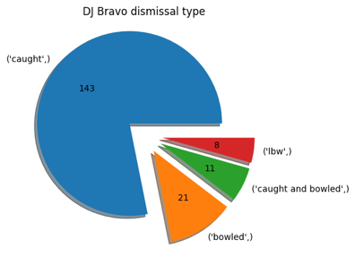 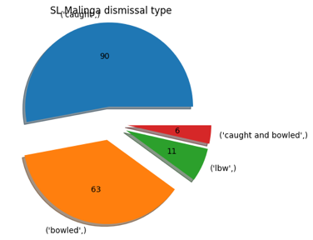 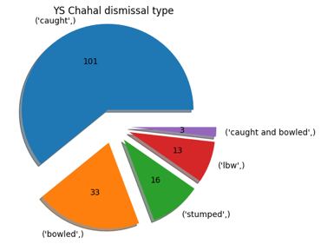

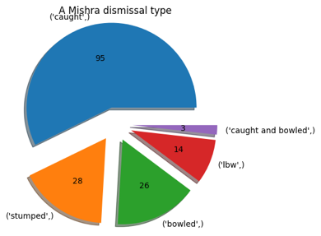 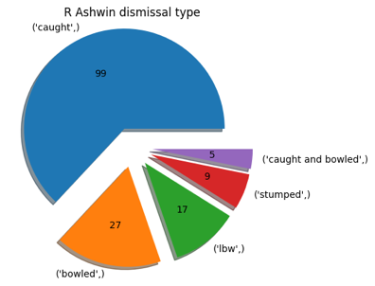 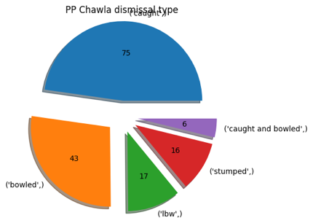

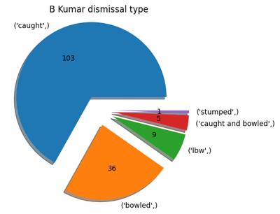 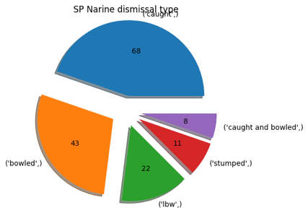 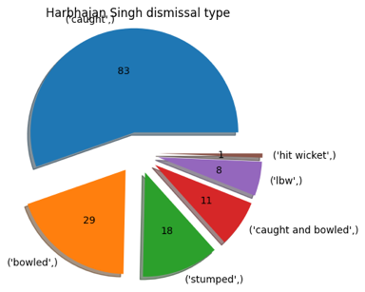

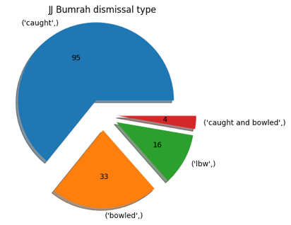

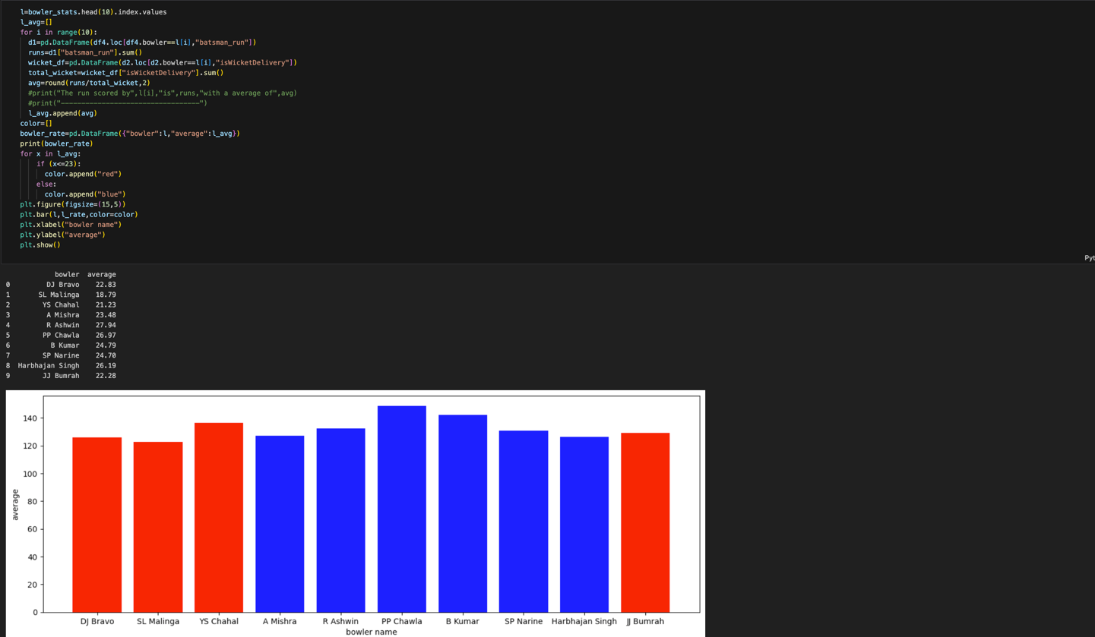

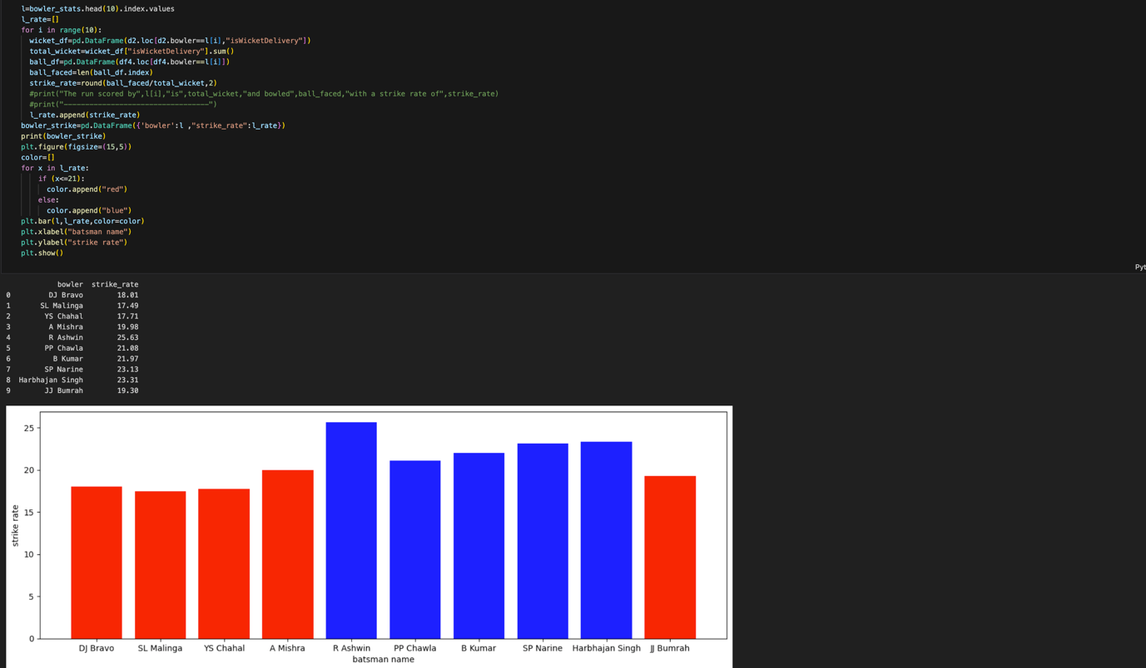

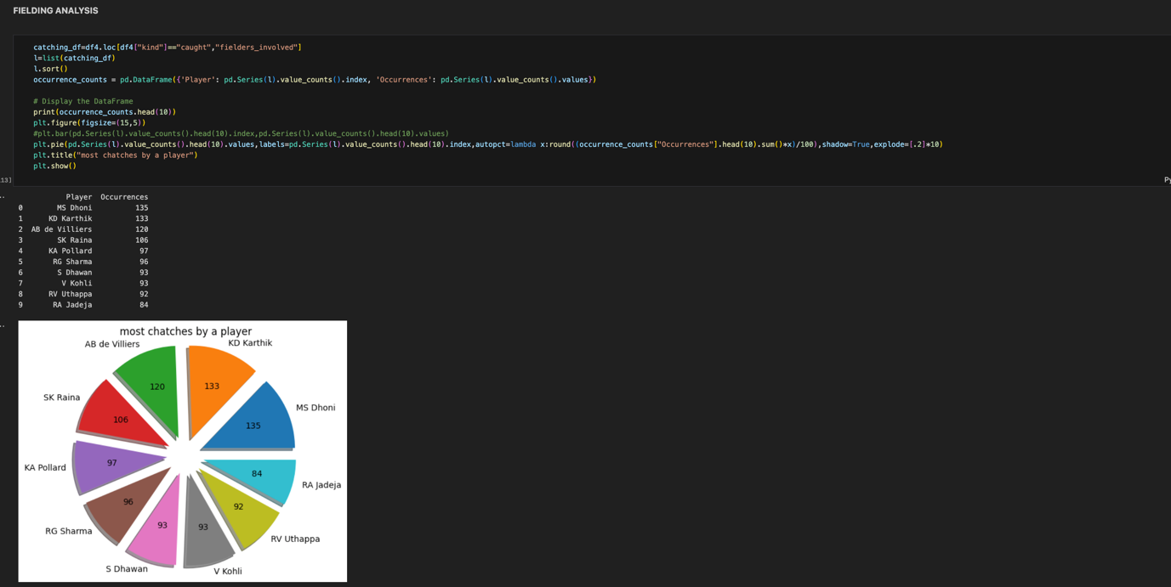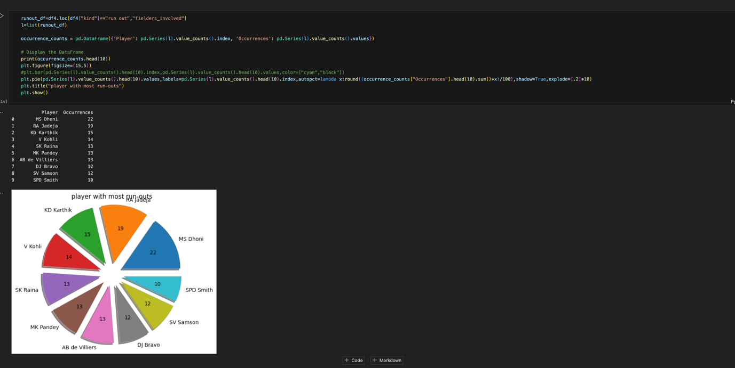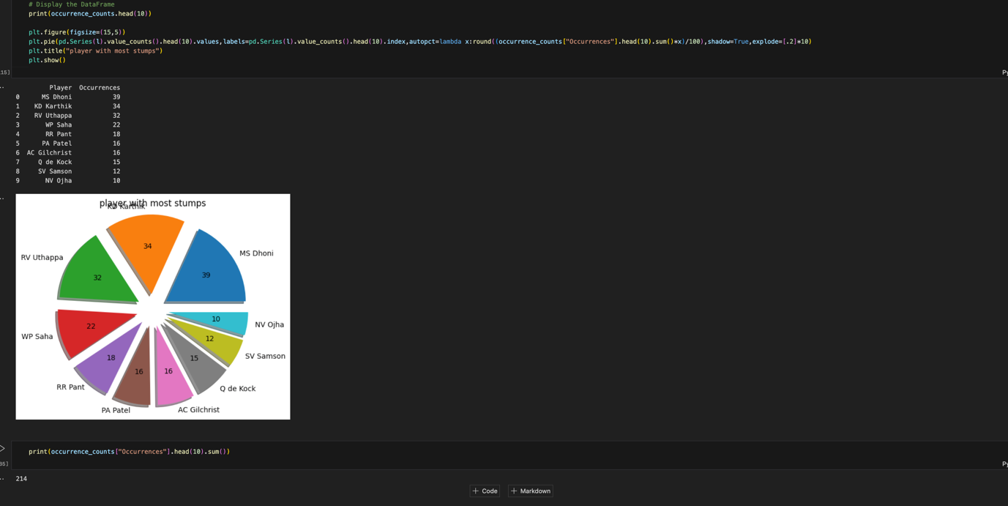

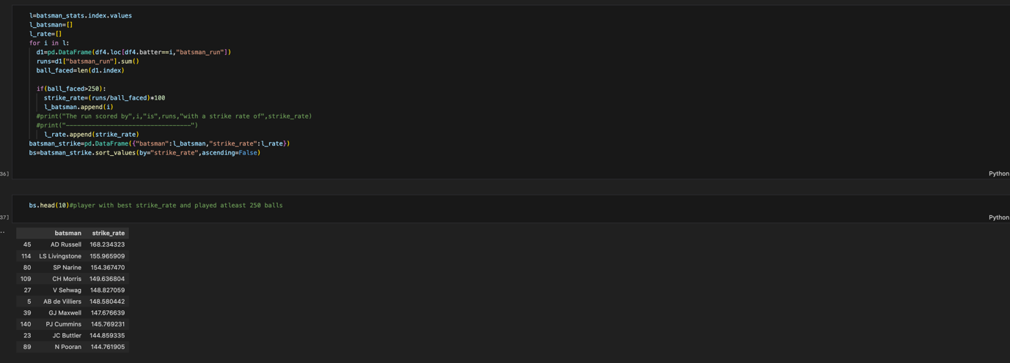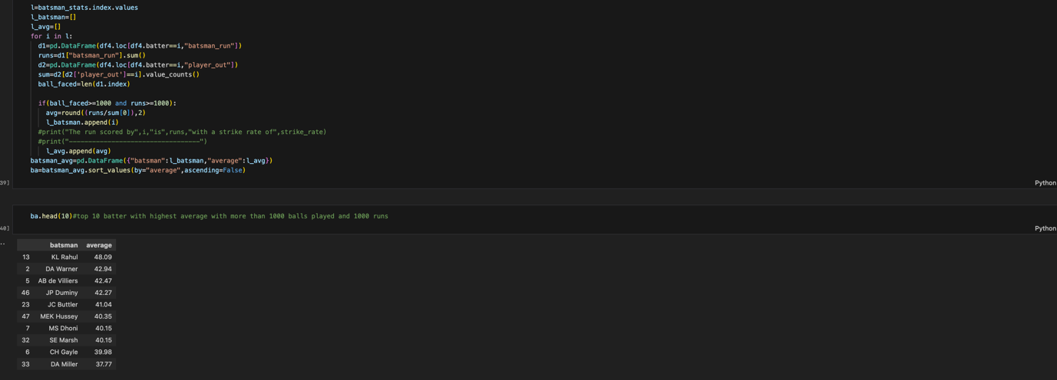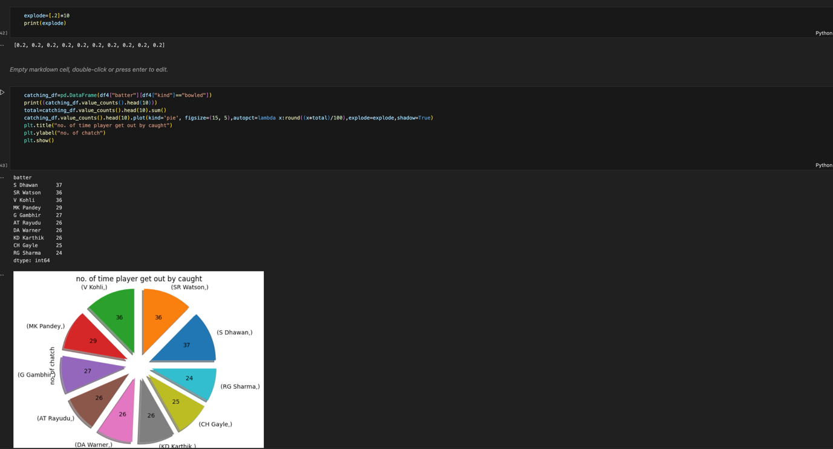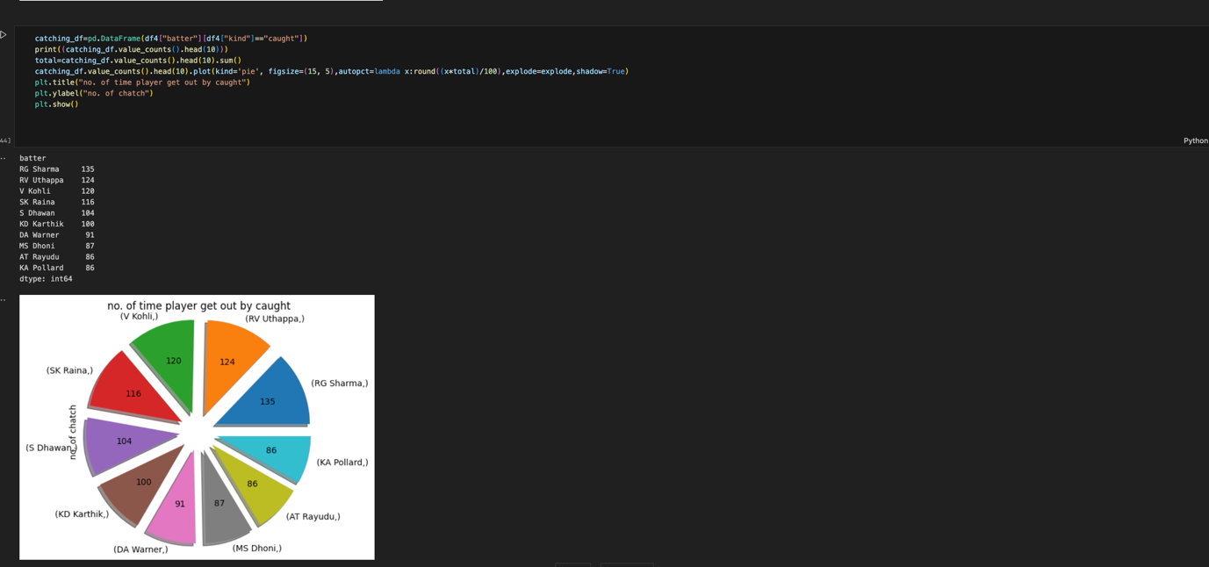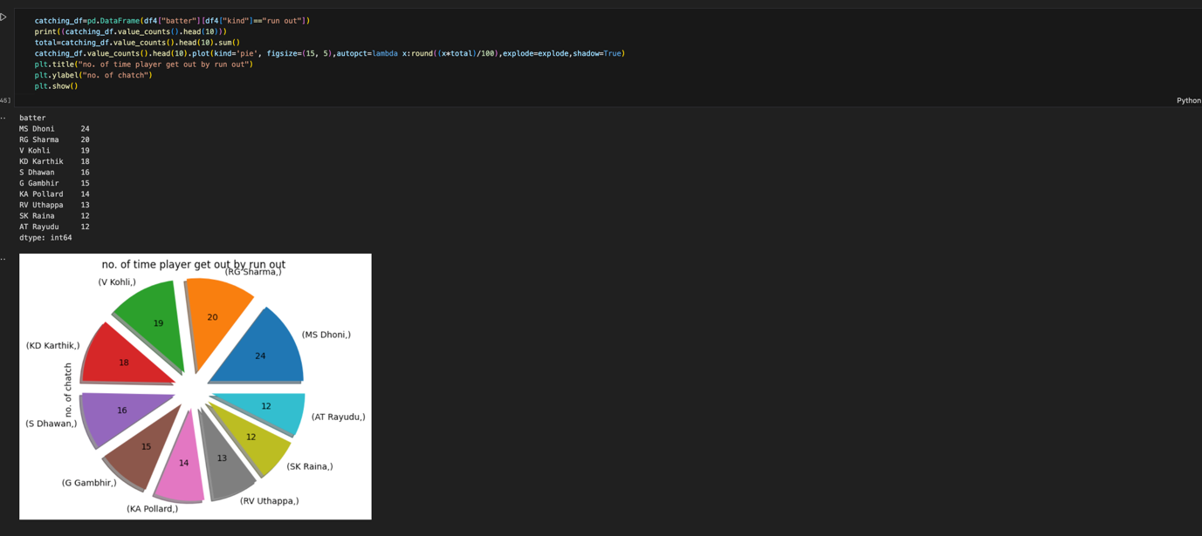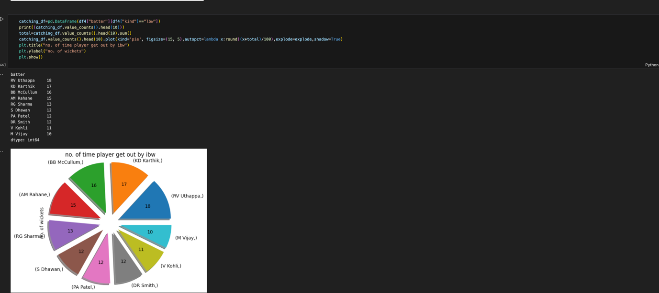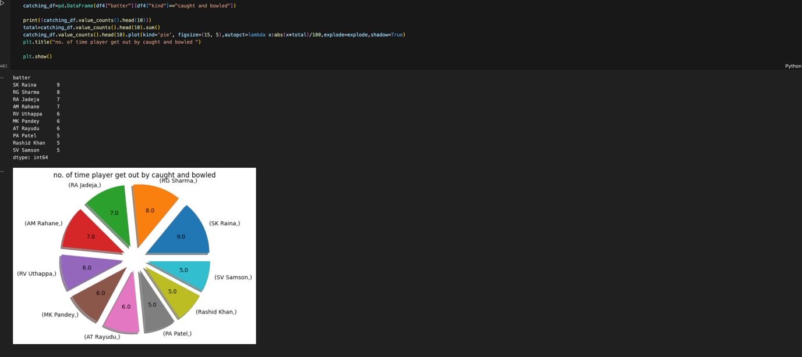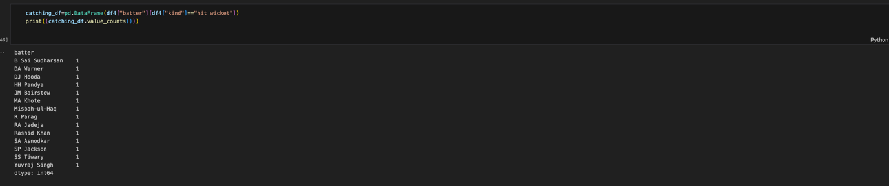

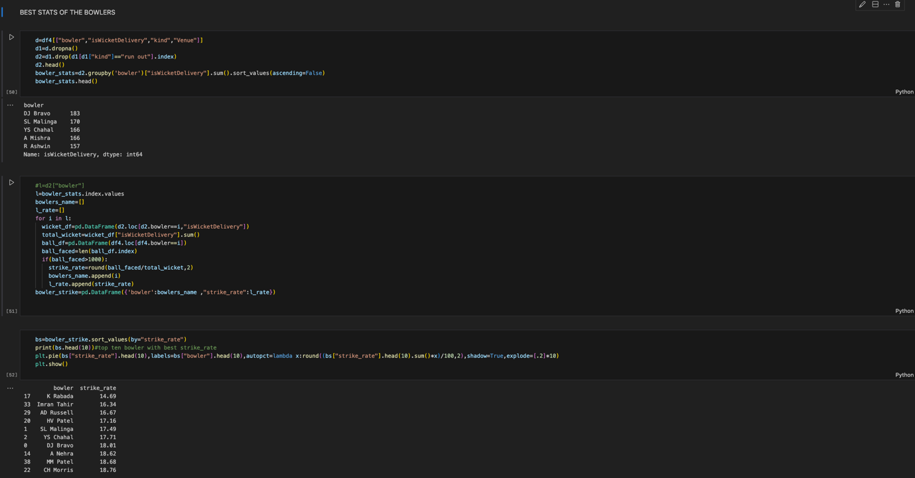

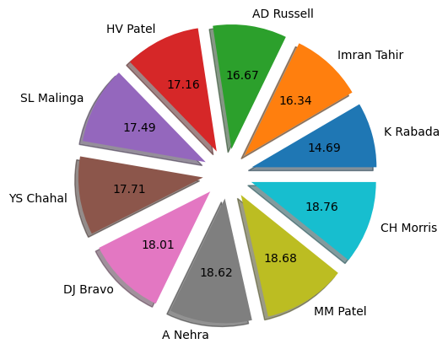

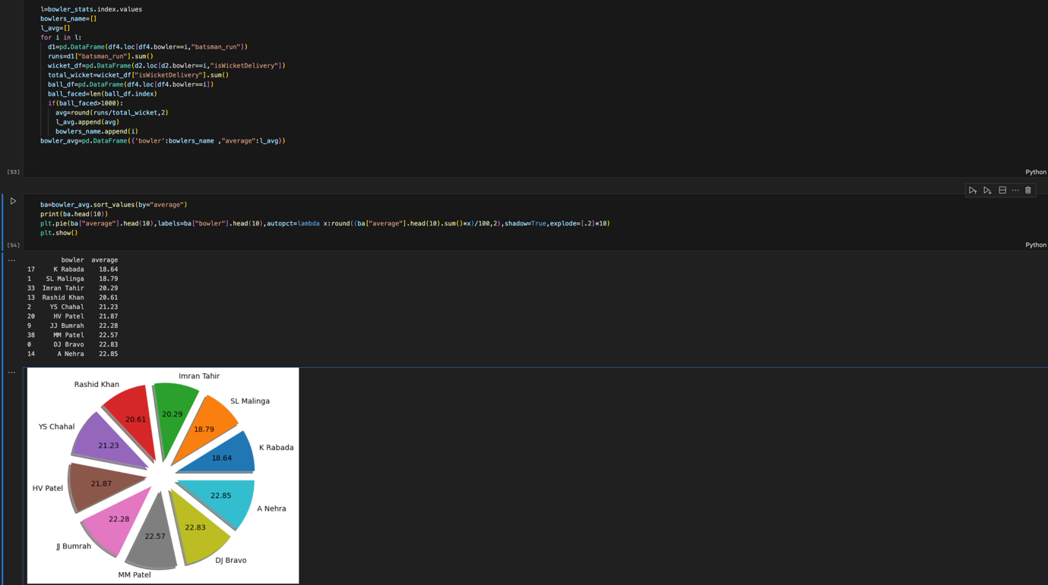

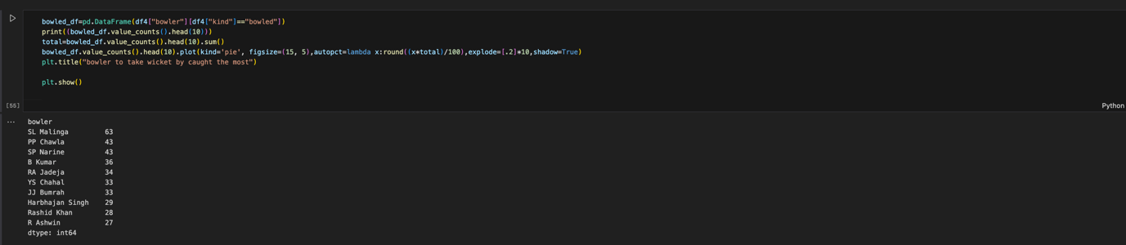

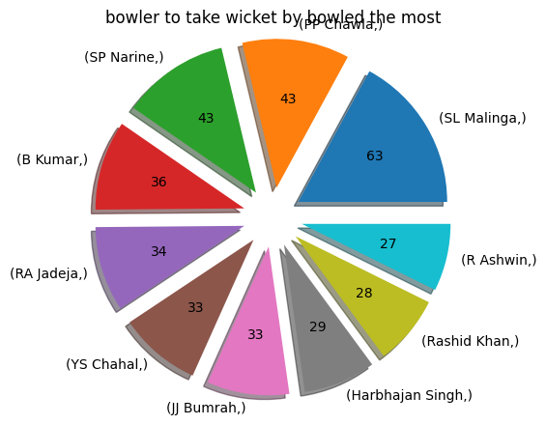

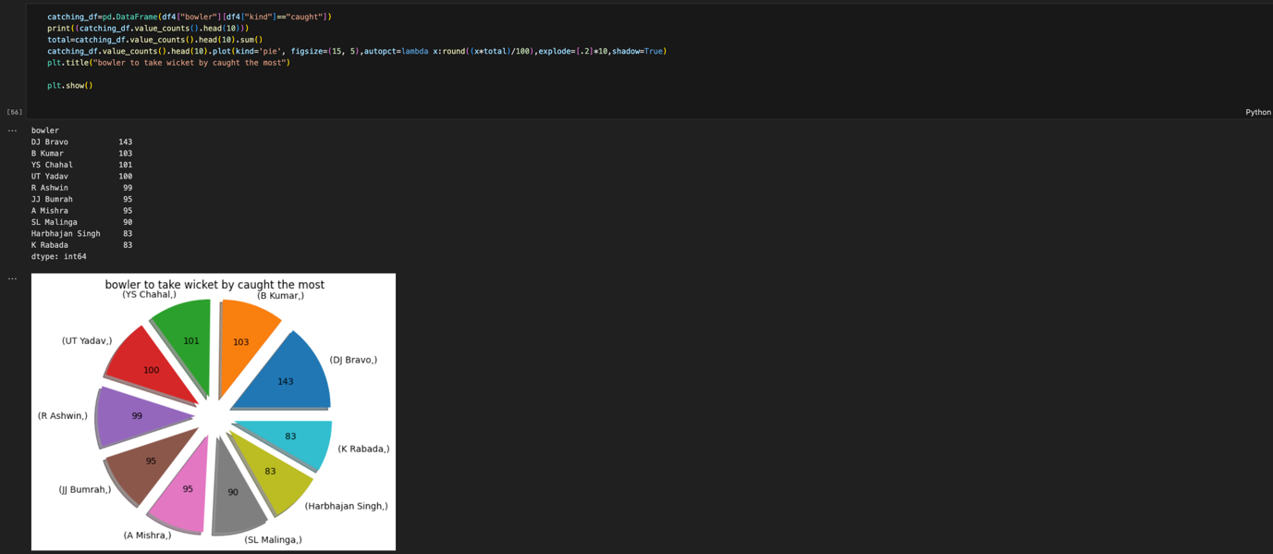

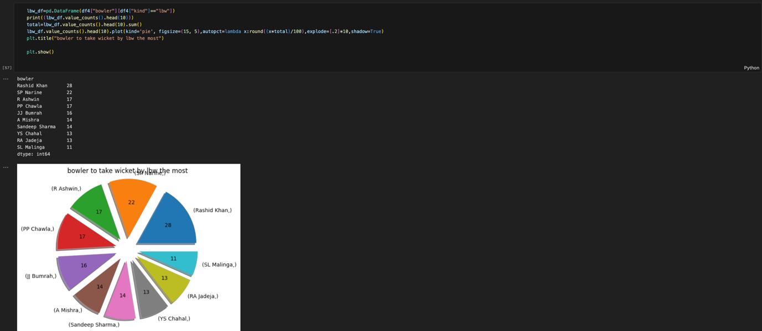

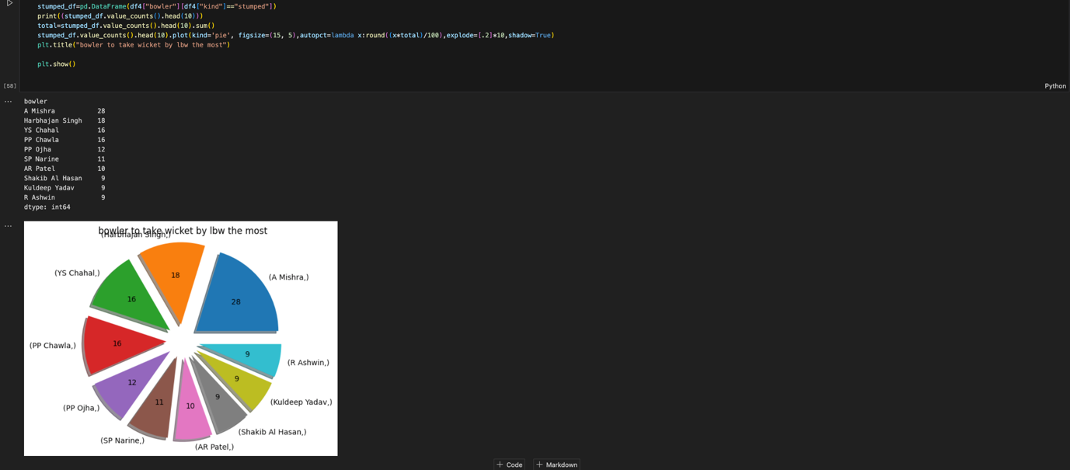

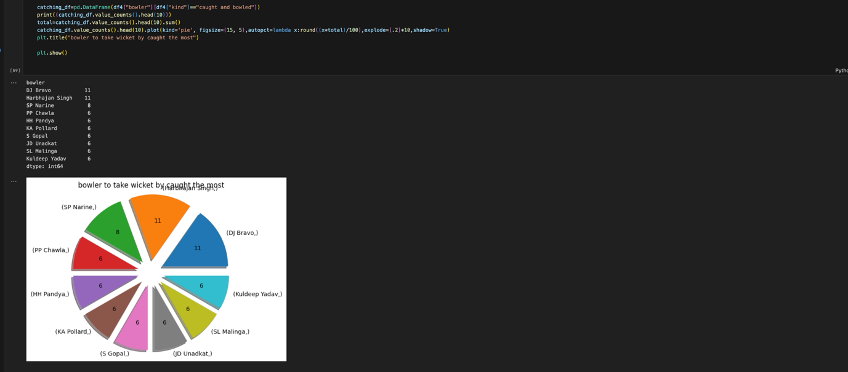

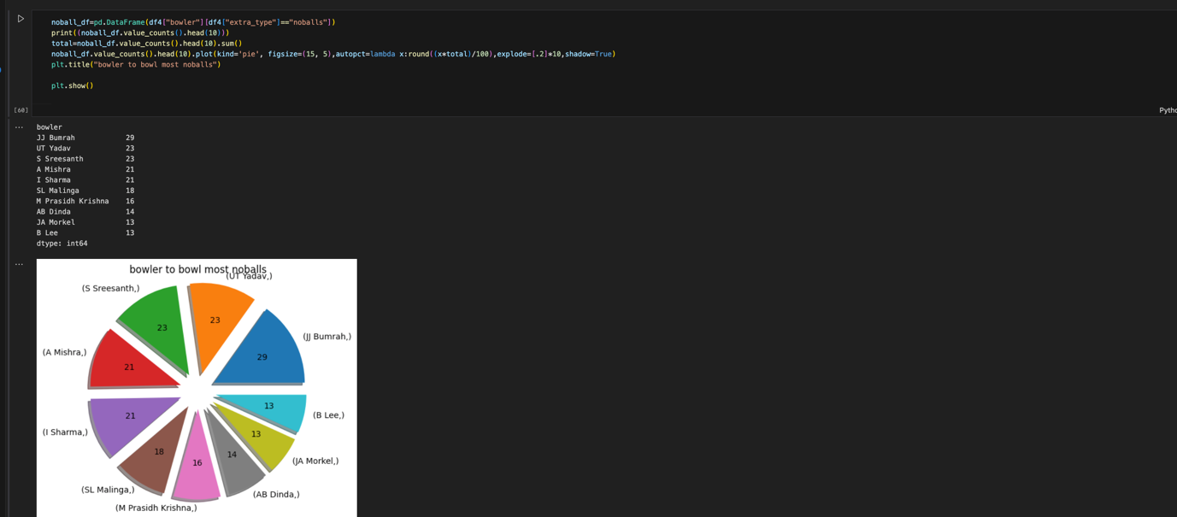

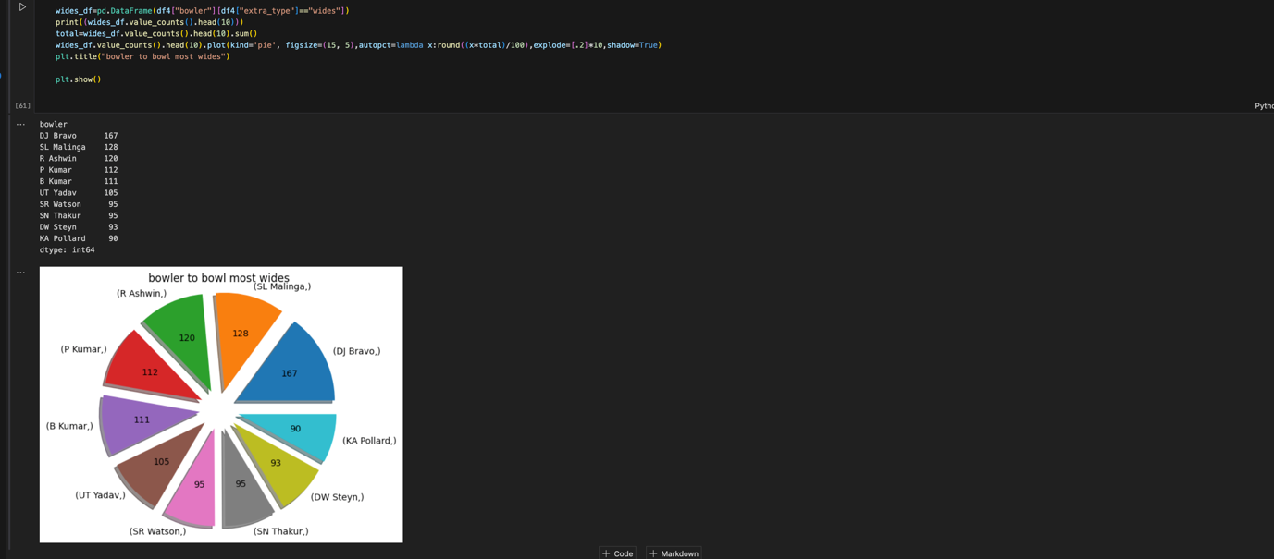

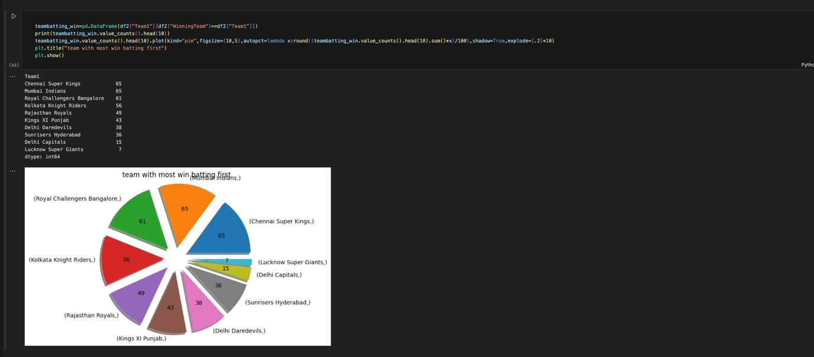

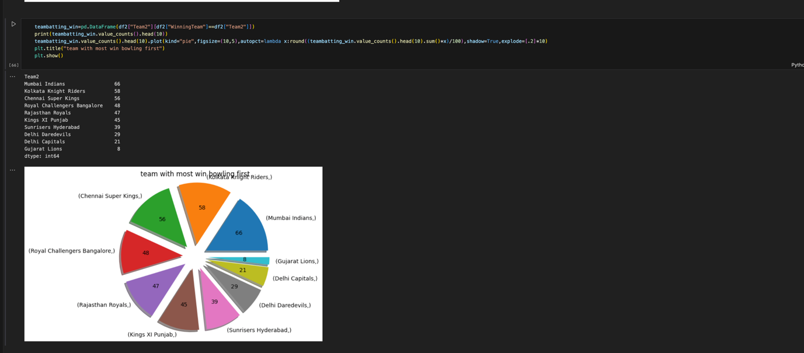

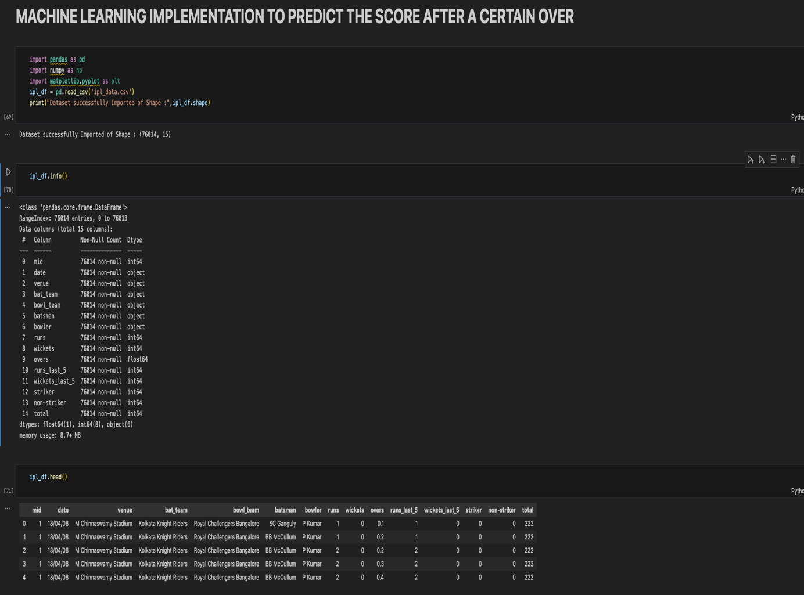

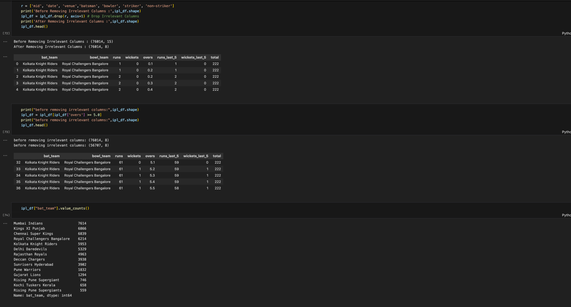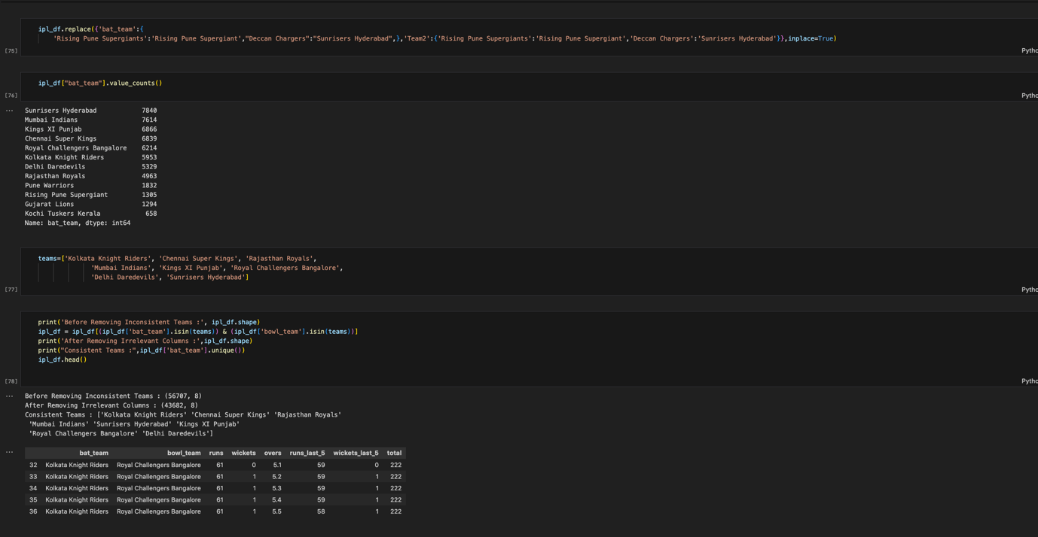

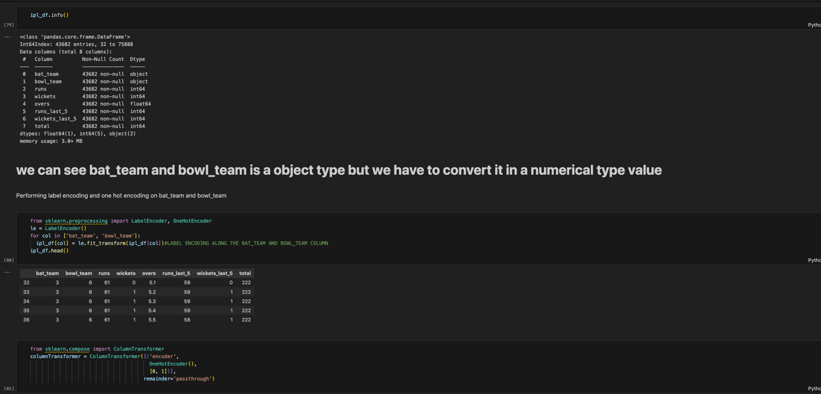

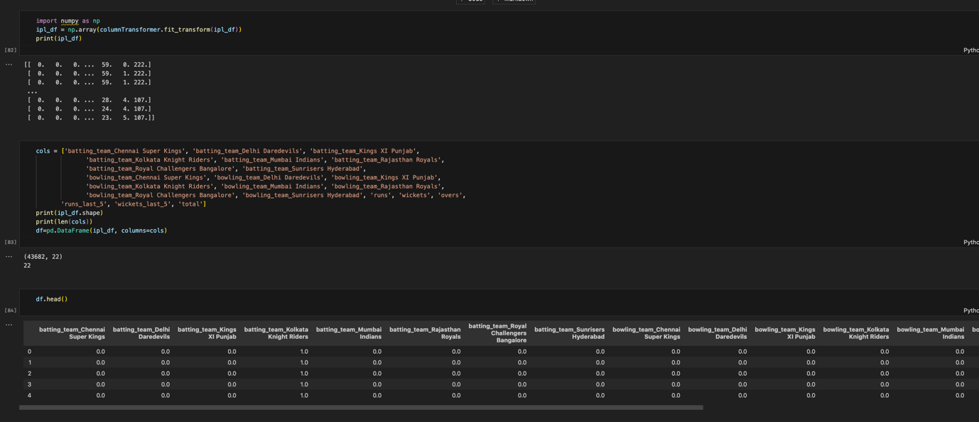

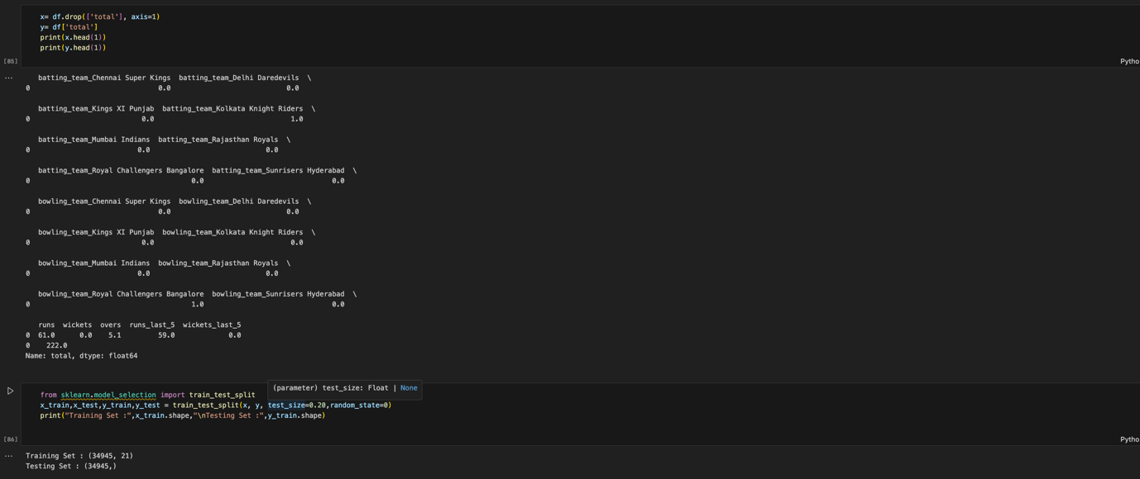

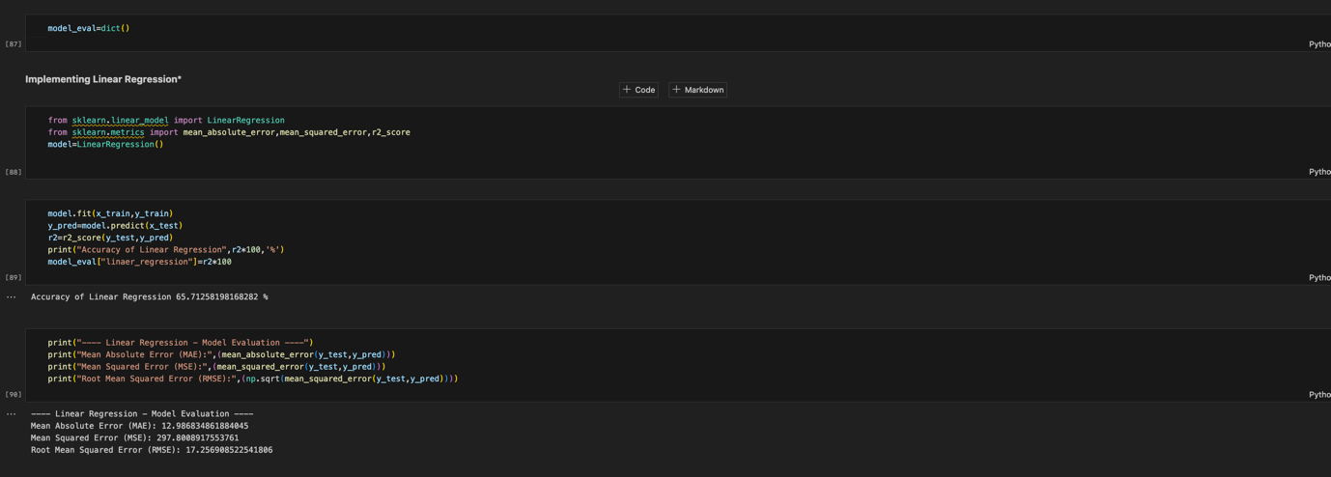

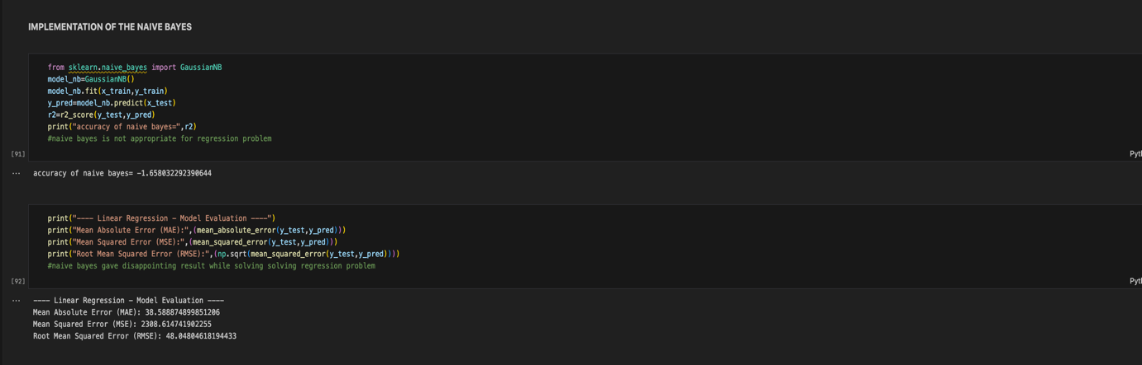

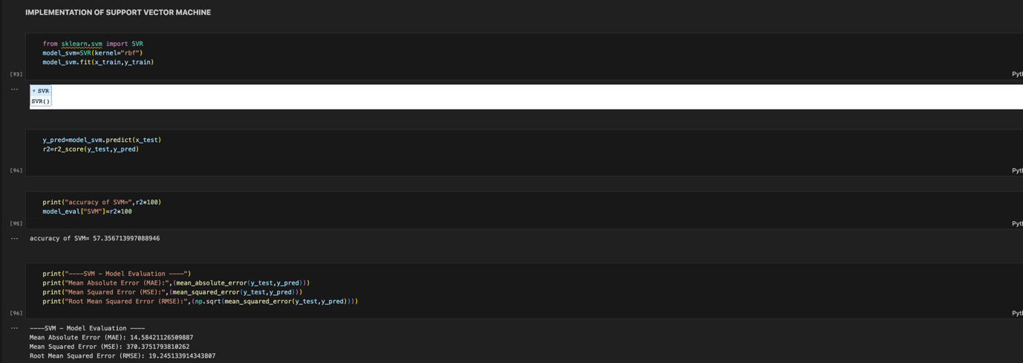

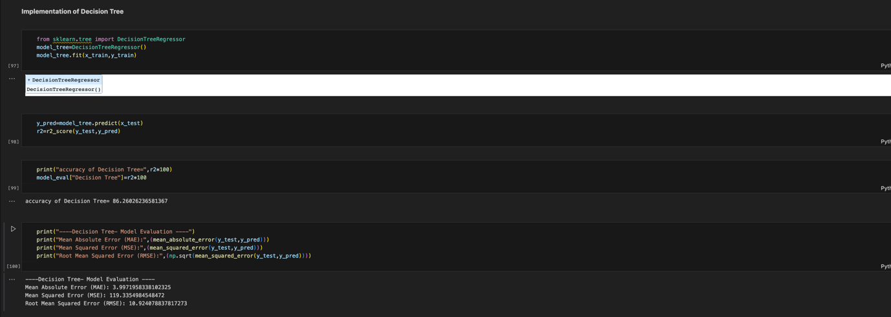

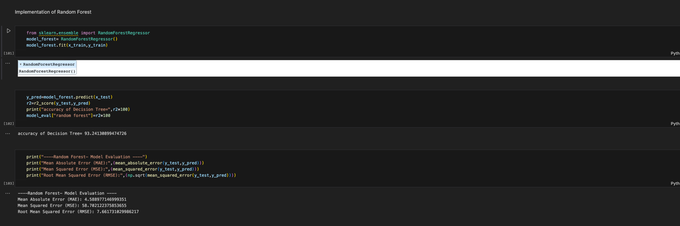

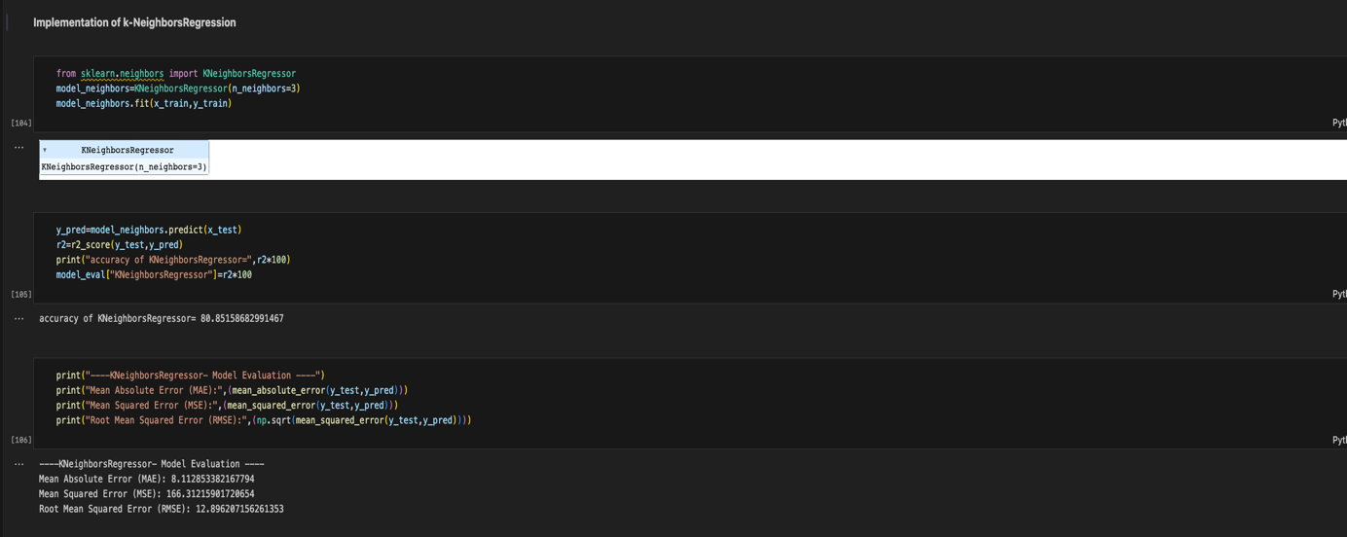

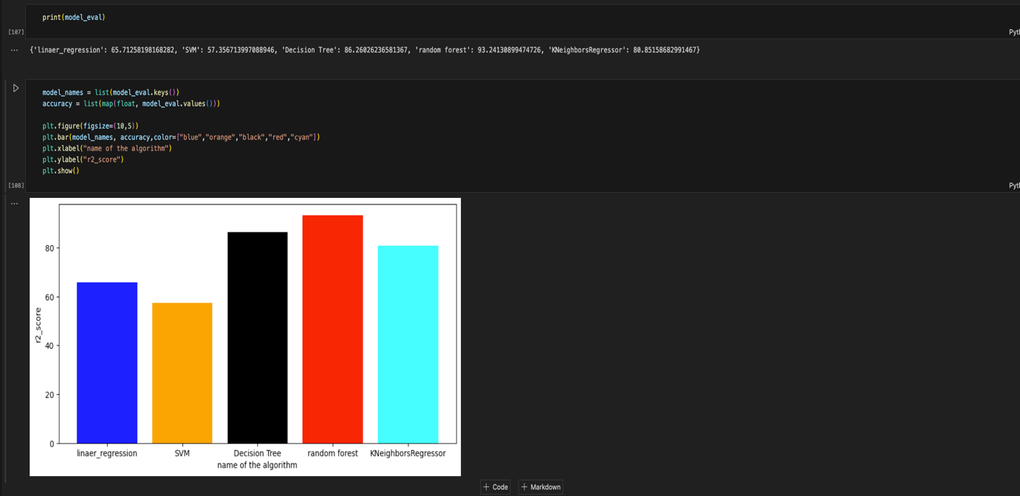

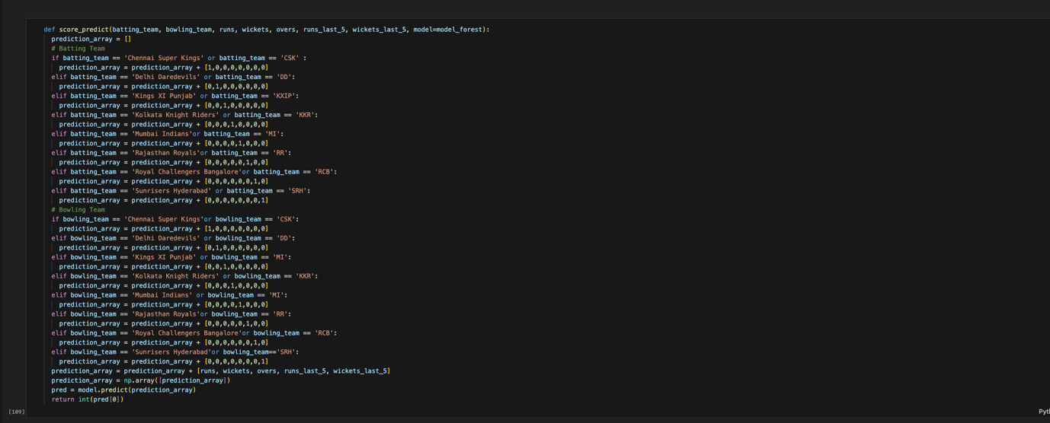

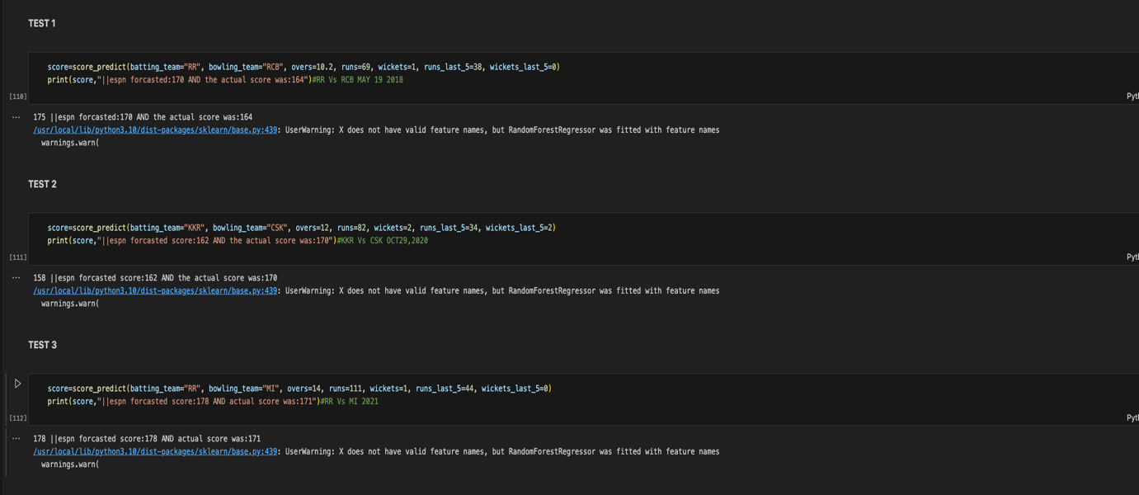

CONCLUSIONS

This project involves a diverse set of machine learning algorithms, each serving specific purposes in predicting IPL match scores. Additionally, the use of specific visualizations like bar graphs and pie charts in Matplotlib enhances the interpretability of your results and aids in conveying insights derived from the data. The combination of data preprocessing, machine learning, and visualization techniques forms a comprehensive and insightful approach to analyzing various aspects of the Indian Premier League.

In conclusion, while the project offers valuable insights for cricket-related analyses and predictions, it is essential to approach the findings with a nuanced understanding of the limitations and considerations inherent in sports analytics. Continuous refinement of models, ethical considerations, and an appreciation for the dynamic nature of cricket are crucial for the project's success in the field of cricket.

FUTURE SCOPE

The future scope of the project on analyzing various aspects of the Indian Premier League (IPL) and predicting match scores using data science and machine learning is promising. Here are some potential avenues for future development and expansion:

**Incorporate More Advanced Machine Learning Models:**

Experiment with advanced machine learning models, such as gradient boosting algorithms (e.g., XGBoost, LightGBM) or neural networks, to explore whether they provide improved predictive performance.

**Feature Engineering and Selection:**

Conduct more in-depth feature engineering to create new relevant features or select the most influential features for better model accuracy.

**Dynamic Model Updating:**

Implement a mechanism for dynamic model updating, allowing the model to adapt to changes in player form, team strategies, or other dynamic factors that influence match outcomes.

**Real-Time Predictions:**

Develop a system for real-time predictions during live matches, incorporating live data feeds to continuously update predictions as the game progresses.

**Ensemble Models:**

Explore the use of ensemble models that combine the strengths of multiple machine learning algorithms to enhance prediction accuracy and robustness.

**Player Injury and Form Prediction:**

Extend the analysis to include factors such as player injuries and predicted player form, which could significantly impact match outcomes.

**Interactive Data Visualization:**

Build interactive dashboards or web applications using tools like Plotly or Dash to allow users, including cricket enthusiasts and analysts, to explore and visualize the data dynamically.